**A**

**Project Report**

**On**

**“Real Estate Management”**

**SUBMITED BY**

Mr. Shubham Sanjay Sahane

**GUIDE By**

**Prof. Kalyani Alisetty**

**Dept. M.C.A.**



**SUBMITTED TO**

**SAVITRIBAI PHULE PUNE UNIVERSITY**

In partial fulfilment of the award of the degree

Of

**MASTERS IN COMPUTER APPLICATION**



**SINHGAD INSTITUTE OF BUSINESS ADMINISTRATION AND RESEARCH**

**KONDHWA, PUNE-411048**

**During Academic Year**

**2021-2022**

**CERTIFICATE OF APPROVAL**

This is to certify that the project report entitled **Real Estate Management** submitted to the Department of Computer Application, Sinhgad Institute of Business Administration and Research in partial fulfillment of the requirement for the award of the Degree of MASTER OF COMPUTER APPLICATIONS (MCA Affiliated to Savitribai Phule Pune University) is an original work carried out by,

Name: **Sahane Shubham Sanjay**

Seat No: **21357**

The matter embodied in this project is a genuine work done by the student and has been certified by the following internal and external examiners deputed by Savitribai Phule Pune University.

Internal Examiner External Examiner

**CERTIFICATE OF ORIGINALITY**

This is to certify that the project report entitled **Real Estate Management** Submitted to the Department of Computer Applications, Sinhgad Institute of Business Administration and Research in partial fulfillment of the requirement for the award of the degree of MASTER OF COMPUTER APPLICATIONS (MCA Affiliated to Savitribai Phule Pune University), is an original work carried out by,

**Mr. Sahane Shubham Sanjay** Exam No: **21357**

under my guidance.

The matter embodied in this project is a genuine work done by the student and has not been submitted whether to this Organization or to any other University/ Organization for the fulfillment of the requirement of any course of study.

Signature of the Student :

Name of the student : Sahane Shubham Sanjay.

Signature of the Guide :

Name and Designation of the Guide : Prof. Kalyani Alisetty

Signature of Director-MCA

**Dr. Netra Patil**  :

Date : **22 / 09 / 2022**

**INDEX**

|  |  |  |
| --- | --- | --- |
| **SR.NO** | **TITLE** | **PAGE** |
| **1** | **INTRODUCTION** |  |
| 1.1  1.2  1.3  1.4 | Introduction  Existing System  Need for System  Limitations of existing system | 1  1  1  1 |
| **2** | **PROPOSED SYSTEM** |  |
| 2.1  2.2  2.3  2.4  2.5  2.6  2.7  2.8  2.9  2.10  2.11 | Proposed System  Problem statement/s  Product overview  Summary of Capabilities  Objective of Proposed System  Functional Requirement’s  Non-Functional Requirement  Users Summary  Scope of System  Module Specification  Operating Environment | 1  1  1  1  1  1  1  1  1  1  1 |
| **3** | **REQUIREMENT AND ANALYSIS** |  |
| 3.1  3.2  3.3 | Fact finding Methods  Feasibility Study  Hardware And Software Requirement | 1  1  1 |
| **4** | **SYSTEM ANALYSIS & DESIGN** |  |
| 4.1  4.2  4.3  4.4  4.5  4.6  4.7  4.8  4.9  4.10  4.11 | Use Case Diagram  Activity Diagram  ER Diagram  Class Diagram  Object Diagram  Web Site Map Design  Component Diagram  Deployment Diagram  Module Specification  User Interface Design (Screens etc.)  Table Specification (Database) | 1  1  1  1  0  0  0 |
| **5** | **USER MANUAL** |  |
| 5.1  5.2  5.3  5.4  5.5 | Menu Explanation  Drawback and Limitations  Proposed Enhancements  Conclusion  Bibliography |  |
|  | **ANNEXURES:** |  |
| 1  2  3 | Output Report with Data  Sample Code  Project Demo |  |

**CHAPTER 1**

**1.1 INTRODUCTION:**

In particular, this Real Estate Management System Project in PHP focuses mainly on publishing and viewing properties. To be more precise, the system helps to keep a number of sales and rental properties. Also, the system contains all the buyers, sellers, and agent information. In addition, the system allows adding up the builder’s account too. Evidently, this project contains an admin panel and a simple client-side. In an overview of this web application, the user can simply register in order to use the features. Here, clients can search for the property details using the state names. As a result, the system filters out all the available properties with detailed information. The user can view property details such as name, location, pricing, features, images, floor plans, and more. In fact, this simple real estate project in PHP exposes the property details to the buyers with the contact information of the sellers.

**1.2 EXISTING SYSTEM:**

* + - The current manual system has a lot of paper work. To maintain the records of sale and service manually, is a Time-consuming task.
    - With the increase in database, it will become a massive task to maintain the database.
    - Requires large quantities of file cabinets, which are huge and require quite a bit of space in the office, which can be used for storing records of previous details.
    - The retrieval of records of previously registered patients will be a tedious task.
    - Lack of security for the records, anyone disarrange the records of your system.
    - Search for Property Online At a fingertip.

**1.3 NEED FOR SYSTEM:**

* + - Our present modern information system makes use of computers for the execution, each of them connected through an optimized network. Real Estate is the most important aspect of our society, and many Real Estate providers face challenges to offer practical and active services to Peoples.
    - Apart from that automating your Real Estate processes and implementing them cannot be done too easily, you need an efficient Real Estate management system to take care of everything that is happening around the Real Estate.
    - If you are ready to implement or go with the Real Estate management system, make sure you follow these things before making it useful in your Real Estate.
    - Processing Speed & Results
    - Cost Effective
    - Reduction in Errors
    - Data Security & Retrieving Ability
    - Improved Patient Care
    - Quality & Compliance

**1.4 LIMITATIONS:**

* + - Lack of security of data.
    - Customer has to Visit Real Estate Office for Searching Property that they needed.
    - Time Consuming.
    - Consumes large Volume of Paper work.
    - Manual Work.
    - No direct role for higher Official.

To Avoid all these limitations and make the system working more accurately it needs to be Computerized.

**CHAPTER 2**

**2.1 PROPOSED SYSTEM:**

Our Real Estate Management System is designed to replace their existing manual paper-based system And Makes property finding, Sales, Rent advertisement To the Digital System.

The new system is to control the information of Property’s With their details and Agent details to contact.

Property availability, Search Property in specific area and submit our own property advertisement, these services are to be provided in an efficient, cost-effective manner, with the goal of reducing the time and resources currently required for such tasks.

**2.2 PROBLEM STATEMENT:**

* + - The current manual system has a lot of paper work. To maintain the records of sale and service manually, is a Time-consuming task.
    - With the increase in database, it will become a massive task to maintain the database.
    - Requires large quantities of file cabinets, which are huge and require quite a bit of space in the office, which can be used for storing records of previous details.
    - The retrieval of records of previously registered patients will be a tedious task.
    - Lack of security for the records, anyone disarrange the records of your system.
    - Search for Property Online At a fingertip.

**2.3 PRODUCT OVERVIEW:**

* + - The Real Estate Management System (REMS) is designed for Real Estate Office to replace their existing manual, paper-based system. The new system is to control the following information; Property information, Availability, Specification and Agent Details, and Users Can Submit Their Own Property. These services are to be provided in an efficient, cost-effective manner, with the goal of reducing the time and resources currently required for such tasks.
    - A significant part of the any Real Estate Organization involves the Property Details, Management of great volumes of information. This information typically involves; Agent contact information and Users Contact information, Flats and Specification of various facilities lists. All of this information must be managed in an efficient and cost wise fashion so that an organization’s resources may be effectively utilized. REMS will automate the management of the Real Estate making it more efficient and error free. It aims at standardizing data, consolidating data ensuring data integrity and reducing inconsistencies.

**2.4 SUMMARY OF CAPABILITY:**

* + - User, Agent, Builder can Register into system.
    - Users can Search Property with different filters like property for sale or rent.
    - Property can be search with property type like flat, villa, office, House, Building.
    - Show recently added property with facilities list and Its cost.
    - Shows contact details of agent for searched property.
    - Floor plan and property photos are also available.
    - Users can Submit their own property for show case on web for rent or sale its facilities and photos with is location.
    - Admin can verifies property and approve it.

**2.5 OBJECTIVE OF PROPOSED SYSTEM:**

Main objectives of a Real Estate System are:

* + - Make a paper-based system to digital system.
    - Make it easy for the Users to search property according to their needs.
    - Make it easy for user to advertise their property.
    - Provide users a simple way to find agent details.
    - Design a system for better Management care.
    - Reduce Manual Document Management Costs.
    - Provide MIS (Management Information System) report on demand to management for better decision making.
    - Better co-ordination among the different Property.
    - Provide top management a single point of control.

Real Estate Management system can be developed by using waterfall model which is a popular version of development life cycle model for software engineering. It describes a development method that is linear and sequential. It has distinct goals for each phase of development. In this model once, a phase of development is completed, there is no turning back, the development proceeds to the next phase. The advantage of this model is that it allows for departmentalization and managerial control.

**2.6 FUNCTIONAL REQUIREMENTS:**

There are a lot of software requirements specifications included in the functional requirements of the Real Estate Management System, which contains various process, namely Registration, Property Search, Agent Contact, and Database.

Registration Process:

* + - Adding Property: The Real Estate Management enables the Employee in the front desk to include new Property to the system.
    - Verifies Properties of Users: The REMS enables the Employees in the front desk to provide a control on properties of users and approved them to the record of the Property. The Users can utilize the registration ID throughout their use of system.

Remove Sold Property:

* + - Deleting Property: The staff in the administration section can delete the Property ID from the system when the Property sold out.
    - Adding to rented list : The Staff in the administration section can put the property in the list of rented properties.

Report Generation:

* + - Information of the Property: The Real Estes Management System generates a report on every property regarding various information like Property name, facilities , Photos , Floor plan ,agent details and more.
    - Availability of the Property: The Real Estate Management system also helps in generating reports on the availability of the property regarding the information like location , size , facilities and more.

Database of SRS:

* + - Mandatory Property Information: Every patient has some necessary data like size ,floor plan, facilities, photos ,agent details etc.
    - Updating information of the property: The real Estate management system enables users to update the information of the property as described in the mandatory information included.

**2.7 Non-Functional Requirements**

There are a lot of software requirements specifications included in the non-functional requirements of the Real Estate Management System, which contains various process, namely Security, Performance, Maintainability, and Reliability.

Security:

* + - Property Identification: The system needs the property to recognize herself or himself using the unique id.
    - Logon ID: Any users who make use of the system need to hold a Logon ID and password.
    - Modifications: Any modifications like insert, delete, update, etc. for the database can be synchronized quickly and executed only by the ward administrator.
    - Front Desk Staff Rights: The staff in the front desk can view any data in the Real Estate Management system, add new patients record to the REMS but they don't have any rights alter any data in it.
    - Administrator rights: The administrator can view as well as alter any information in the Real Estate Management System.

Performance:

* + - Response Time: The system provides acknowledgment in just one second once the properties information is checked.
    - Capacity: The system needs to support at least 1000 people at once.
    - User-Interface: The user interface acknowledges within five seconds.
    - Conformity: The system needs to ensure that the guidelines of the Microsoft accessibilities are followed.

Maintainability:

* + - Back-Up: The system offers the efficiency for data backup.
    - Errors: The system will track every mistake as well as keep a log of it.

Reliability:

* + - Availability: The system is available all the time.

Hope you got a clear idea on the functional and non-functional requirements and the features required by the hospital. Any other queries on the topic are welcome.

**2.8 USERS SUMMARY:**

* + - Admin that manages users’ property and views reports.
    - Builder that manages their plat that advertised for rent or sale.
    - Agent that manage their details and property
    - People that use system for property search

**2.9 SCOPE OF THE SYSTEM:**

* + - Users can Submit their own property for listing with their complete details and photo’s
    - Enforces Proper report Generation at all times.
    - Search Property at any time at any ware to fulfil need.
    - A user-friendly graphical interface.
    - Provide Agent Details.
    - Make an Enquiry for Property
    - Admin manage state and city too so only those address property can be submitting.

**2.10 MODULES SPECIFICATIONS**

1. Admin :
   * + Manage users of Real Estate.
     + Watch property submitted by user, builder, agent.
     + View property of patient and update details.
     + View Enquiry and Feedback given by users
     + Add State And City from Which property have to be accept.
2. User :
   * + View Property’s list and status of sale or rent with its facilities.
     + View photos, floor flan details And location details.
     + Manage Property Submited.
     + Manage own profile.
     + View Agent Detail for searched property.
3. Agent :
   * + View Property’s list and status of sale or rent with its facilities.
     + View photos, floor flan details And location details.
     + Manage Property Submited.
     + Manage own profile.

**CHAPTER 3**

**3.1 FACT FINDING METHODS:**

A database developer commonly uses several fact-finding techniques during a single database project.

There are five widely used fact-finding techniques:

* + - Examining documentation
    - Interviewing
    - Observing the enterprise in action
    - Research
    - Questionnaires

Let us discuss in brief each of them:

1. Examining documentation: can be helpful when you try to gain some insight as to how the requirement for a database arose. You may also find that documentation can help to acquire information on the part of the enterprise associated with the problem. If the problem relates to the current system, there should have to be documents associated with that system. By examining documents, forms, reports, and files associated with the current system, you can quickly gain some thoughtful concepts out of the system.
2. Interviewing: is the most frequently used, and usually the most useful, fact-finding procedure used. We can interview to collect information from person face-to-face. There can be several objectives for using interviewing, such as finding out facts, verifying those facts, clarifying these released facts, generating enthusiasm, getting the end-user involved, identifying requirements, and gathering ideas and opinions. However, using the interviewing practice must require proper communication skills for dealing effectively with people who have different values, priorities, opinions, motivations, and personalities.
3. Observing the enterprise in action: Observation is one of the most successful fact-finding techniques carried out for understanding a system. Using this technique, it is achievable to either participate in or observe a person perform activities to learn about the system.
4. Research: A useful fact-finding technique is to research the application or the problem that you are dealing with and want to put within a database. Computer trade journals, reference books, and the Internet are good sources of information that can make available the vast quantity of information on how others have solved similar problems/issues plus whether or not any software packages exist to resolve or even partially solve your current problem.
5. Questionnaires: Another fabulous fact-finding method is to conduct surveys through questionnaires. Questionnaires are special-purpose documents that allow facts to be gathered from a large number of people while upholding some control over their responses. When dealing with a large number of listeners or audience, no other fact-finding technique can tabulate the same facts so efficiently. There are two types of questions that can be asked in a questionnaire, namely free-format and fixed-format. Free-format questions offer the respondent greater freedom inputting answers. Fixed-format questions require specific responses from individuals, and for the given question, the respondent must choose from the available answers.

**3.2 HARDWARE AND SOFTWARE REQUIREMENT:**

|  |  |  |  |  |
| --- | --- | --- | --- | --- |
| **Item** | **Web server (minimal)** | **Web server (recommended)** | **Combined Web & Database Server (minimal)** | **Combined Web & Database Server (recommended)** |
| Processor | 1.6 GHz CPU | 2 x 1.6 GHz CPU | 2 x 1.6 GHz CPU | 4 x 1.6 GHz CPU |
| RAM | 1-1.75 GB | 3-5 GB | 3-5 GB | 7 GB |
| HDD | 1x 100 GB of free space or more is recommended for data (non-system drive is preferred) 1x 20 GB of free space is recommended for the software’s (system drive) | | | |
| Operating System | Windows* Server, Linux*, or any operating system that can run as a webserver, capable of delivering HTML5, JavaScript content, including JSON and MP4. | | | |
| .NET Framework | Microsoft .NET Framework 4.5 | | | |
| Software Requirements for Web Servers | Internet Information Services (IIS) 6, 7.0, 7.5 or 8,  Windows PowerShell 2.0, 3.0 or 4.0,  Apache, MySQL | | | |
| Software Requirements for Users | Any latest Browser or preceding 2 versions of that Browser. | | | |

**3.2 FEASBILITY STUDY:**

Technical Feasibility:

* + - The technical feasibility carried out for this system determined whether the planned system could be developed and design in organization using the existing technology.
    - The existing system can have expertise to use it. The organization is already equipped with require hardware and software.
    - The hardware currently available has enough memory to support software. Hence this system technically feasible.

Economical Feasibility:

* + - While considering the economical feasibility it is checked inn points like performance, information, and output from this system.
    - Economic of system at financial experts of project. It determines whether the investment that goes into the implementation of system is recoverable.
    - As the hardware and software are already available and no investment are to be made in that direction. Thus system is economical feasible.

Operational Feasibility:

* + - Operational feasibility ends at checking if the system will work in more efficient and accurate manner through all routine operations.
    - This system is made to be comprehensive in nature using a full menu driven system & appropriate user informative messages.
    - No training is required, User can easily operate the system.
    - Our system is user friendly, View of system is very simple that for not trouble for handling user.

**CHAPTER 4**

**4.1 USE CASE DIAGRAM:**

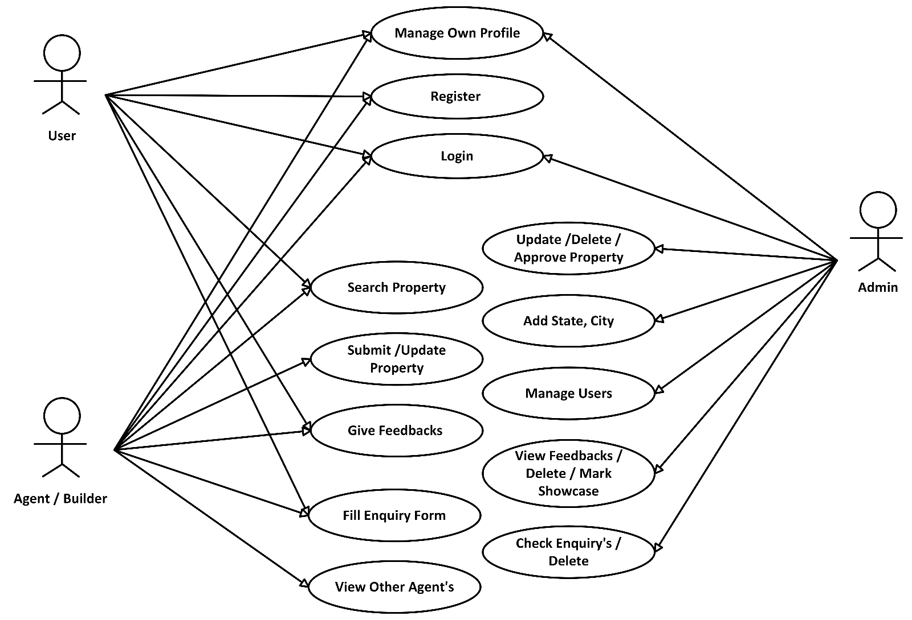

**4.2 ACTIVITY DIAGRAM:**

1. **Admin:**

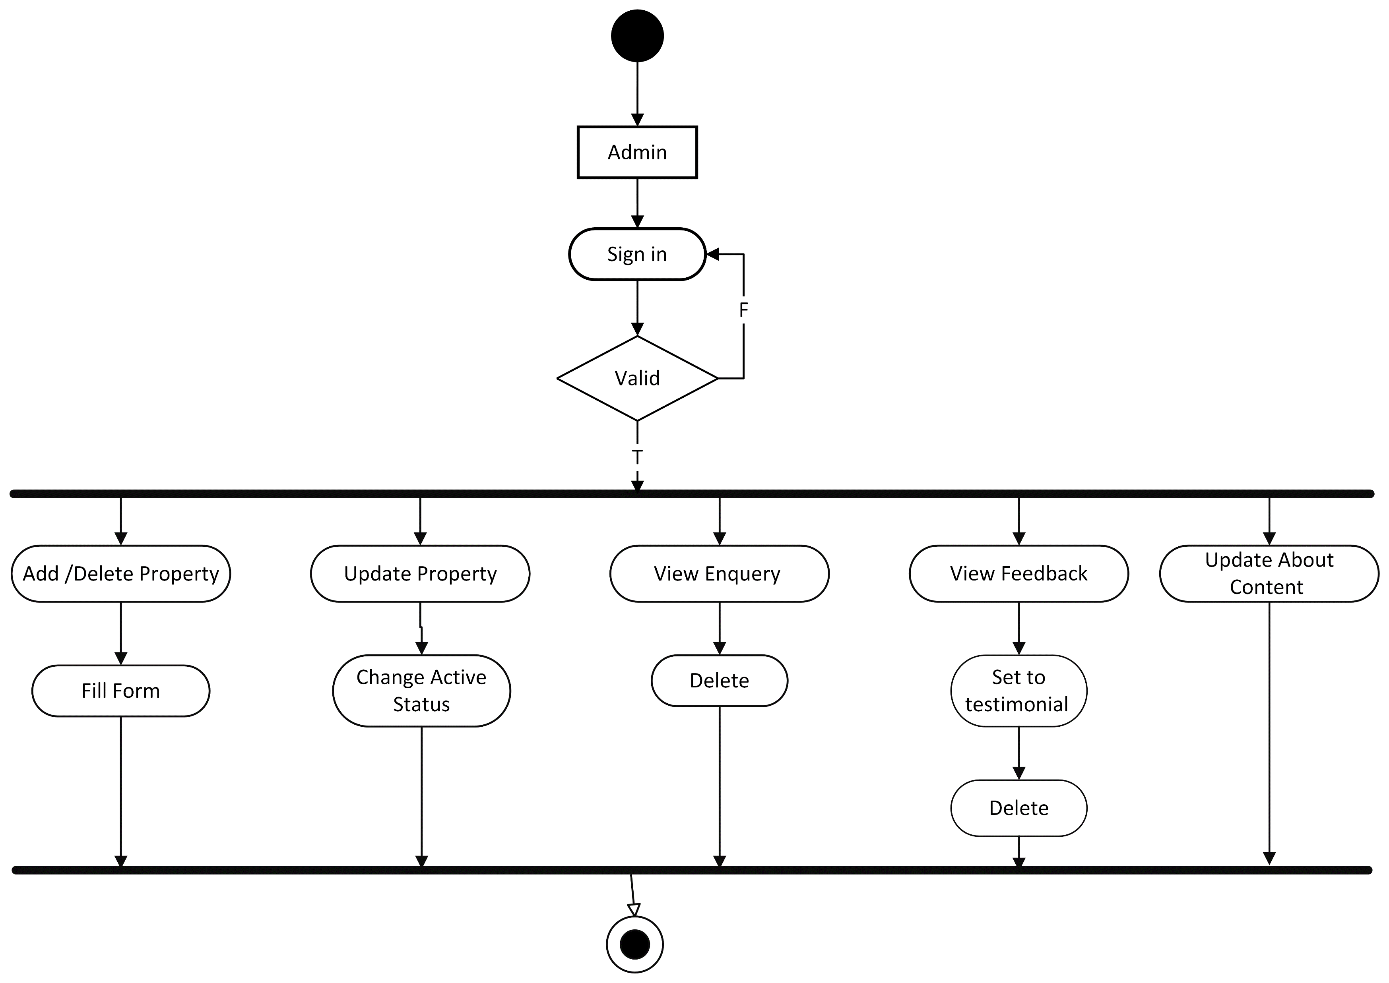

1. **Agent/Builder , User:**

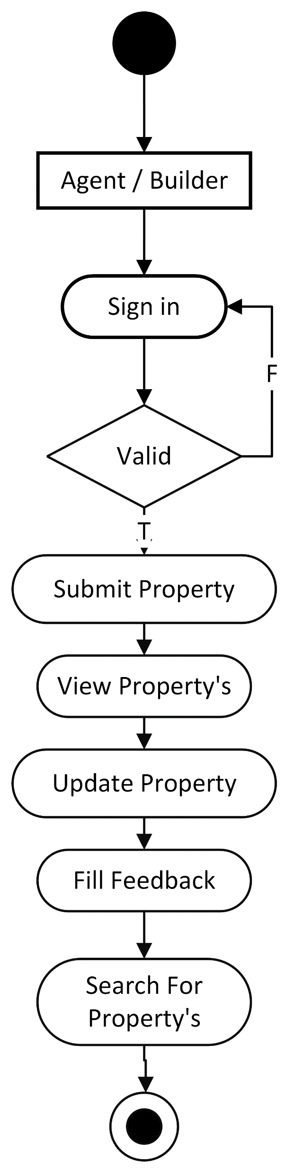 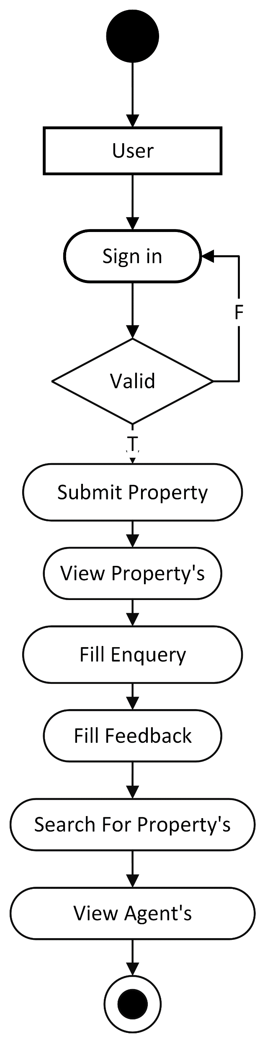

**4.3 ER DIAGRAM:**

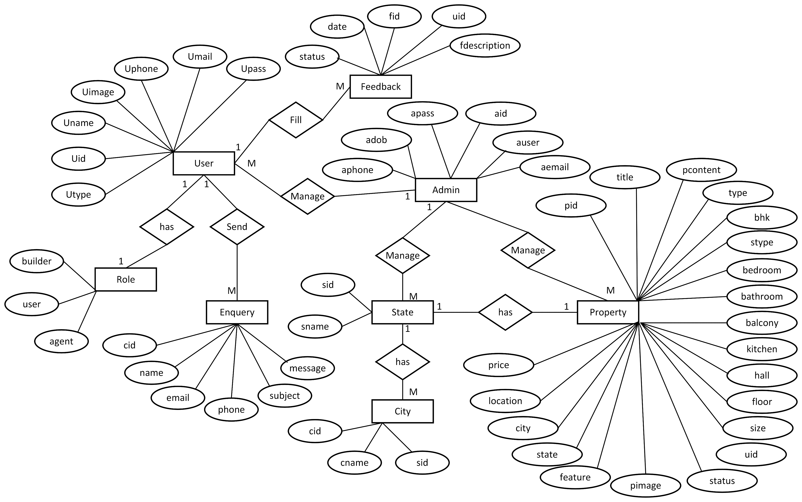

**4.4 CLASS DIAGRAM:**

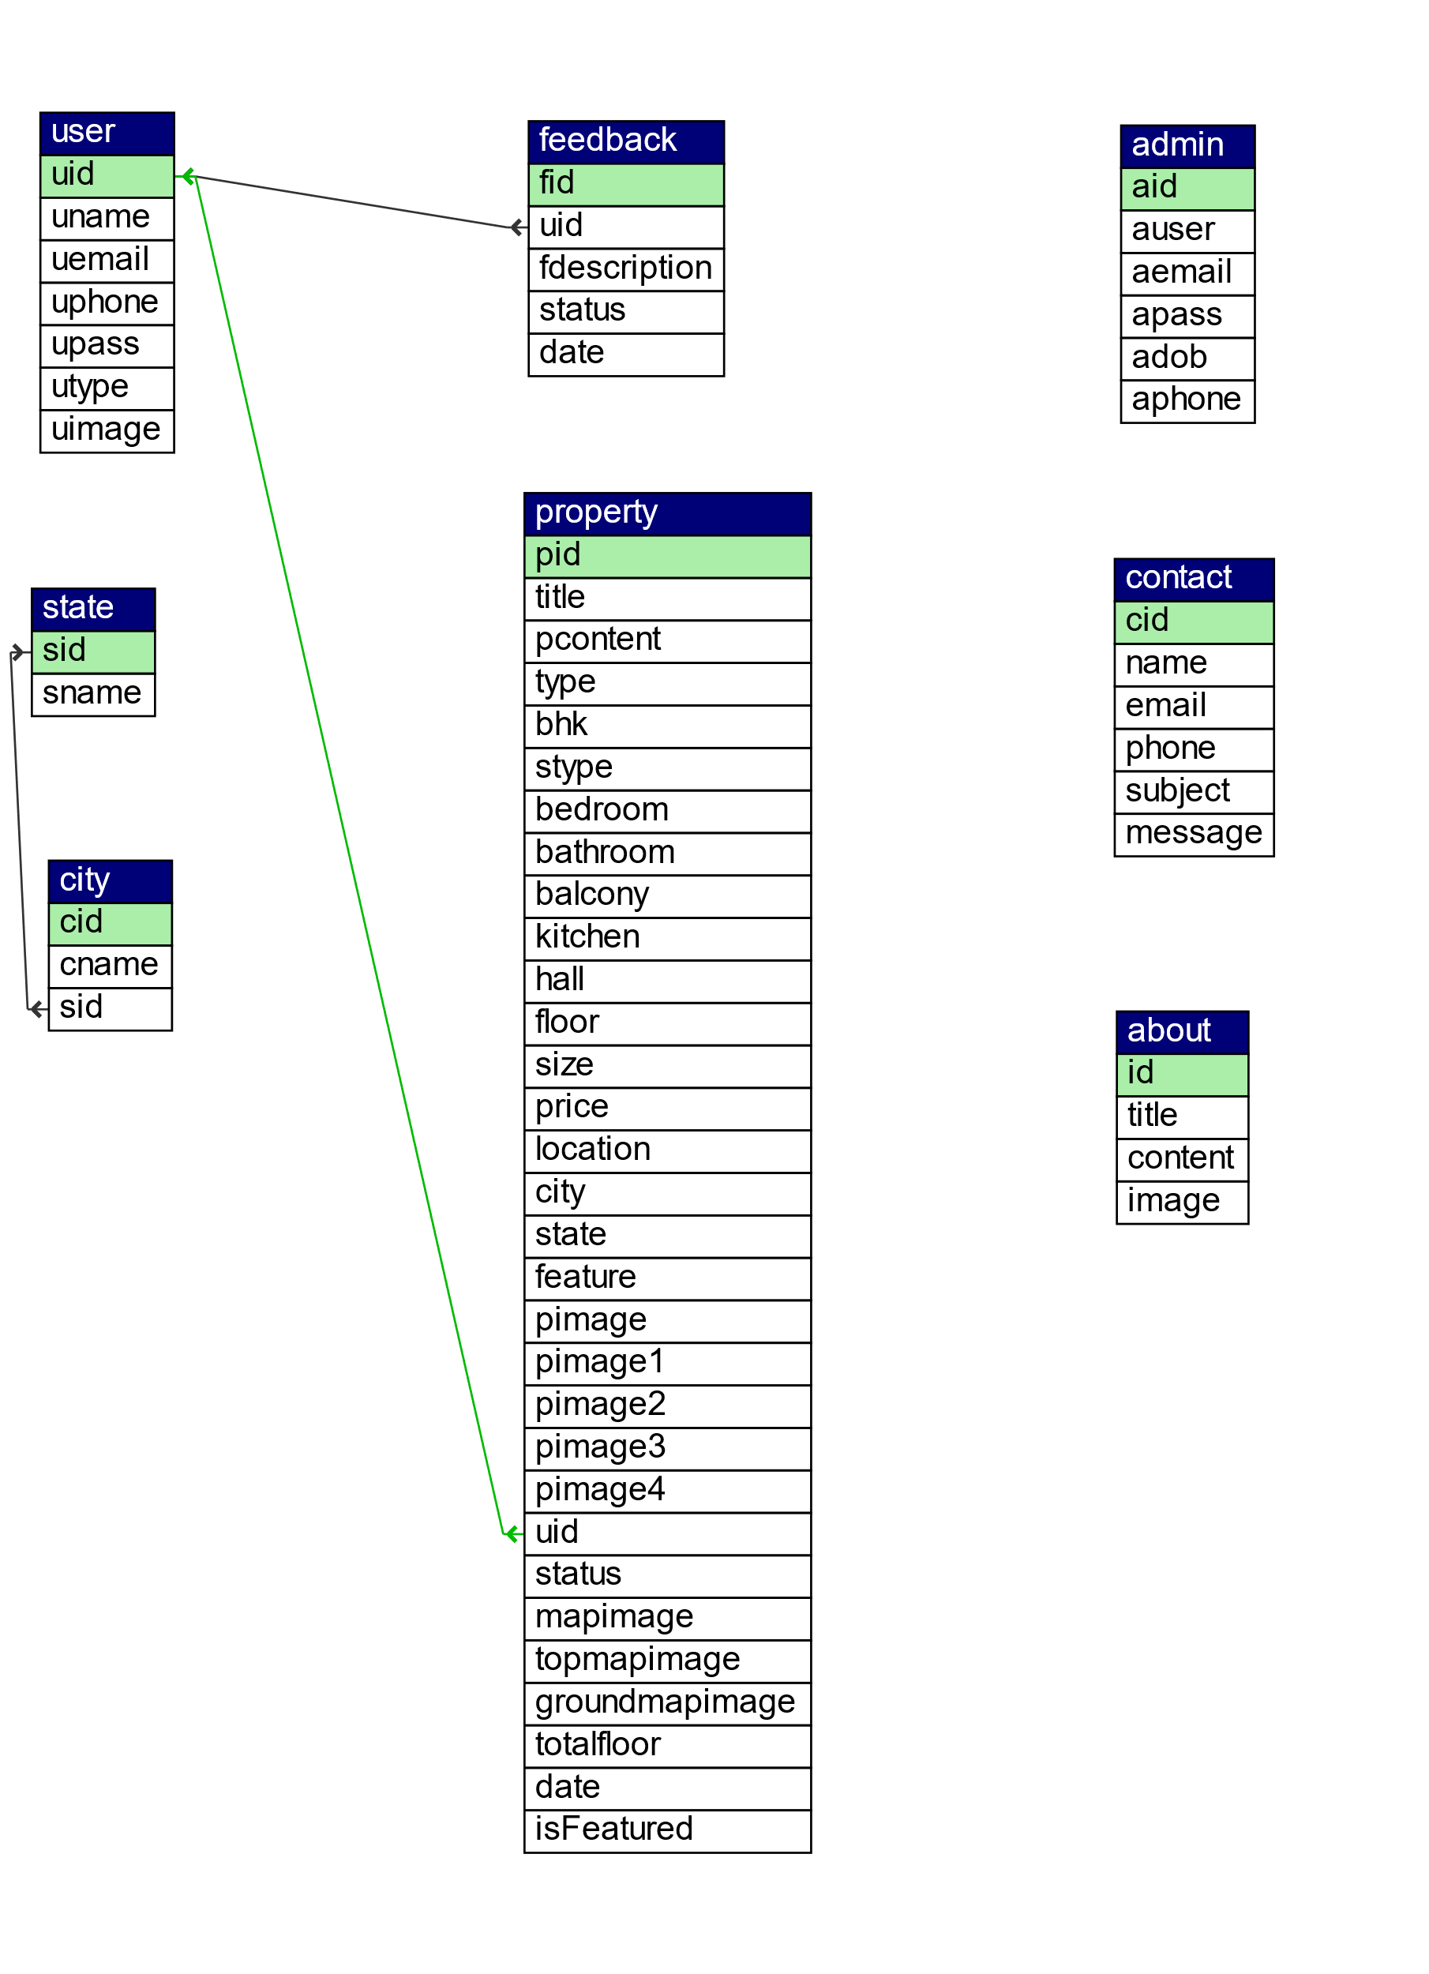

**4.5 OBJECT DIAGRAM:**

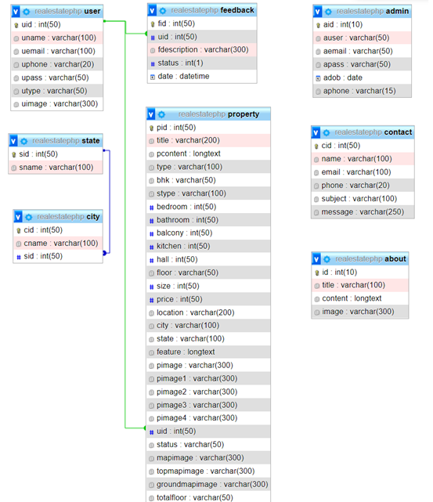

**4.6 WEB SITE MAP:**

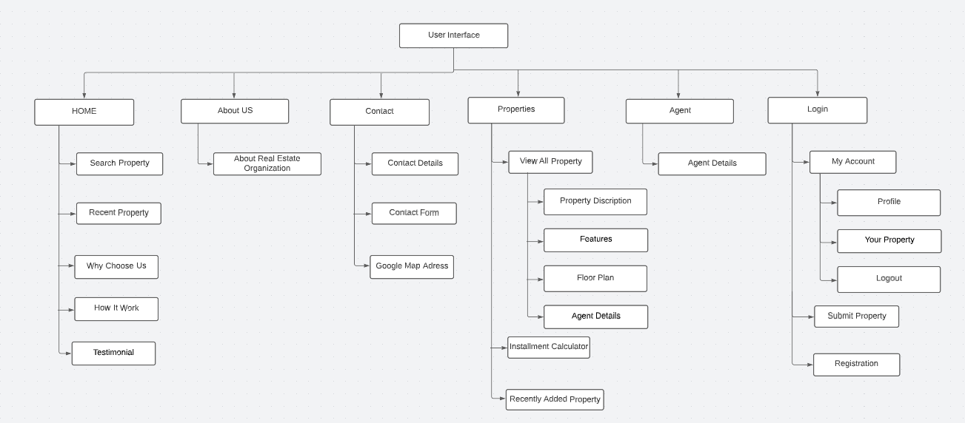

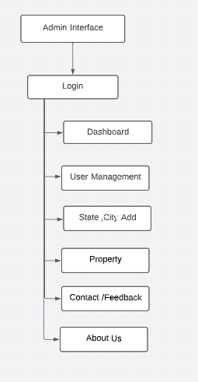

**4.7 COMPONENT DIAGRAM:**

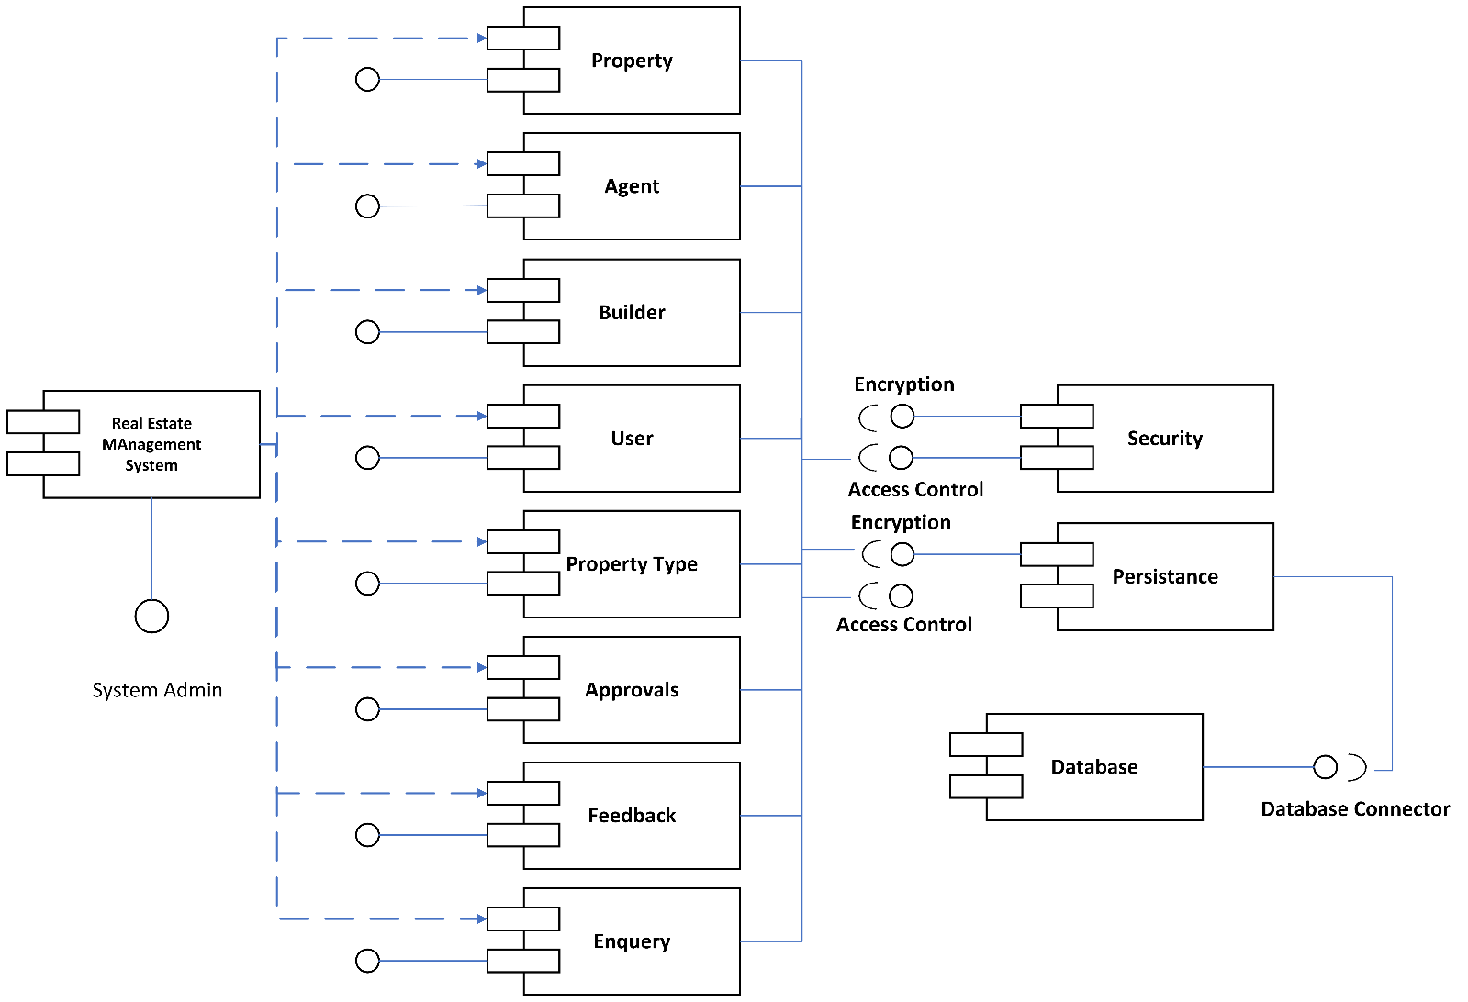

**4.8 DEPLOYMENT DIAGRAM:**

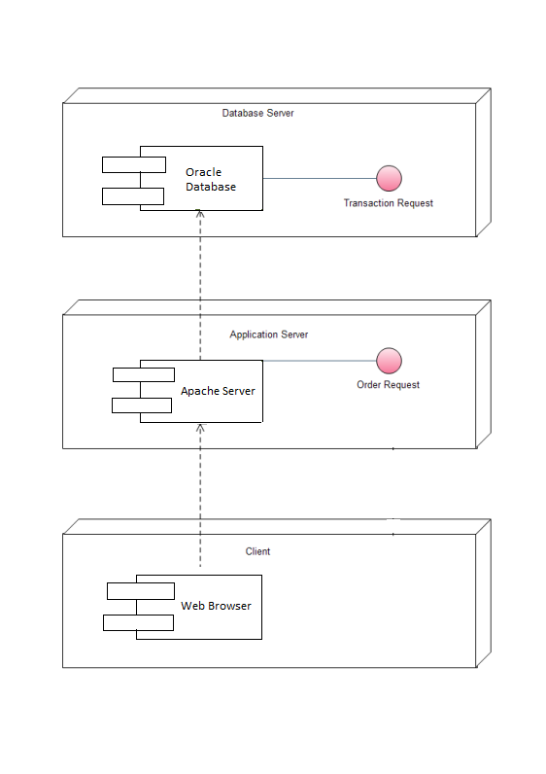

**4.9 MODULE SPECIFICATION:**

**1) Page Details: Property Seller, Instalment Calculator**

* + - When it comes to projects such as real estate systems, the user should also be able to submit their property for sale, and rental purposes. And there is one. The user has to provide a large number of property details. It includes the name of the property, description, pricing details, locations, number of images, features, and much more. With it, the user can also set the property to feature status(codeastro.com). Talking about the featured status, the website simply lists out the top featured properties in the right-hand sidebar. Not just it, every user can list and manage their posted property in order to manage their status. Additionally, the system contains an important feature; an instalment calculator which helps to figure out the total amount that should be paid by the buyers within the instalment period. For that, the user has to enter the total duration with amount and percentage.

1. **Page Details :Admin Panel**
   * + An administrator has full control over the system. He/she can manage all the users, states and cities, properties, and so on. Here, each and every section has its own respective details such as name, and other important details. Here, an admin can list out a number of registered users with their levels. The user level consists of admin, agents, builders, and clients. The very first thing of management for the administrator side is to set up state and city information. And with it(codeastro.com), the administrator can also manage properties. In terms of property management, the admin can list out all the available properties. With it, the administrator can make changes to any of the available ones. In fact, the administrator him/herself can post property details following the procedure of it. In addition to it, the admin can have an overview of the system’s record from the dashboard.
2. **Page Details: Contact, Feedback Management and Web Info**
   * + When it comes to projects such as real estate systems, the user should also be able to submit their property for sale, and rental purposes. And there is one. The user has to provide a large number of property details. It includes the name of the property, description, pricing details, locations, number of images, features, and much more. With it, the user can also set the property to feature status(codeastro.com). Talking about the featured status, the website simply lists out the top featured properties in the right-hand sidebar. Not just it, every user can list and manage their posted property in order to manage their status. Additionally, the system contains an important feature; an instalment calculator which helps to figure out the total amount that should be paid by the buyers within the instalment period. For that, the user has to enter the total duration with amount and percentage.

**4.10 User Interface Design (Screens etc.) : Home**

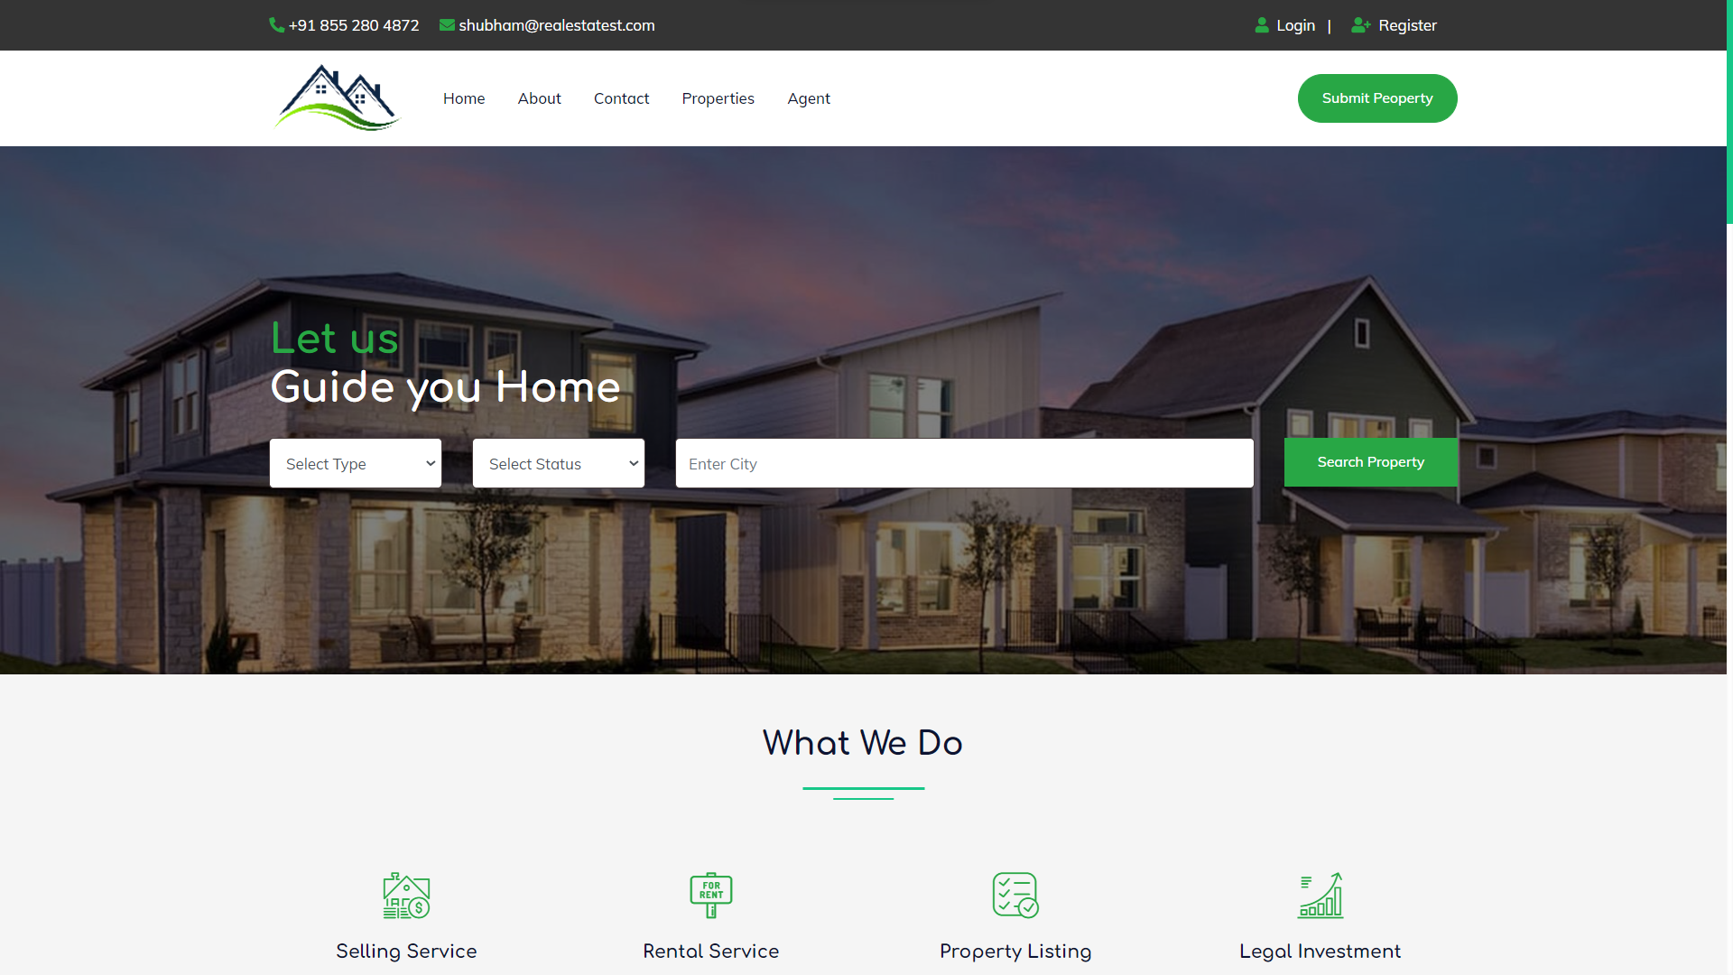

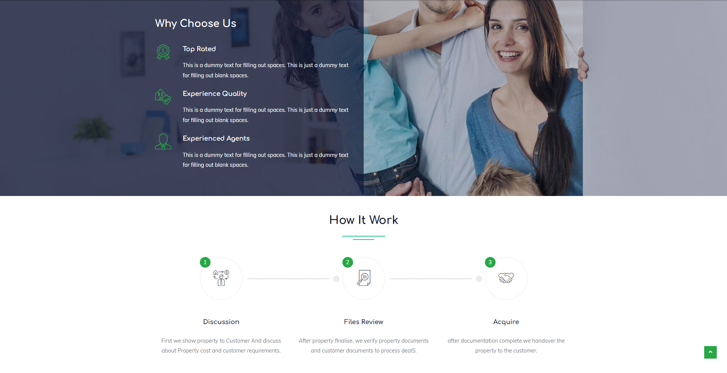



**About Us:**

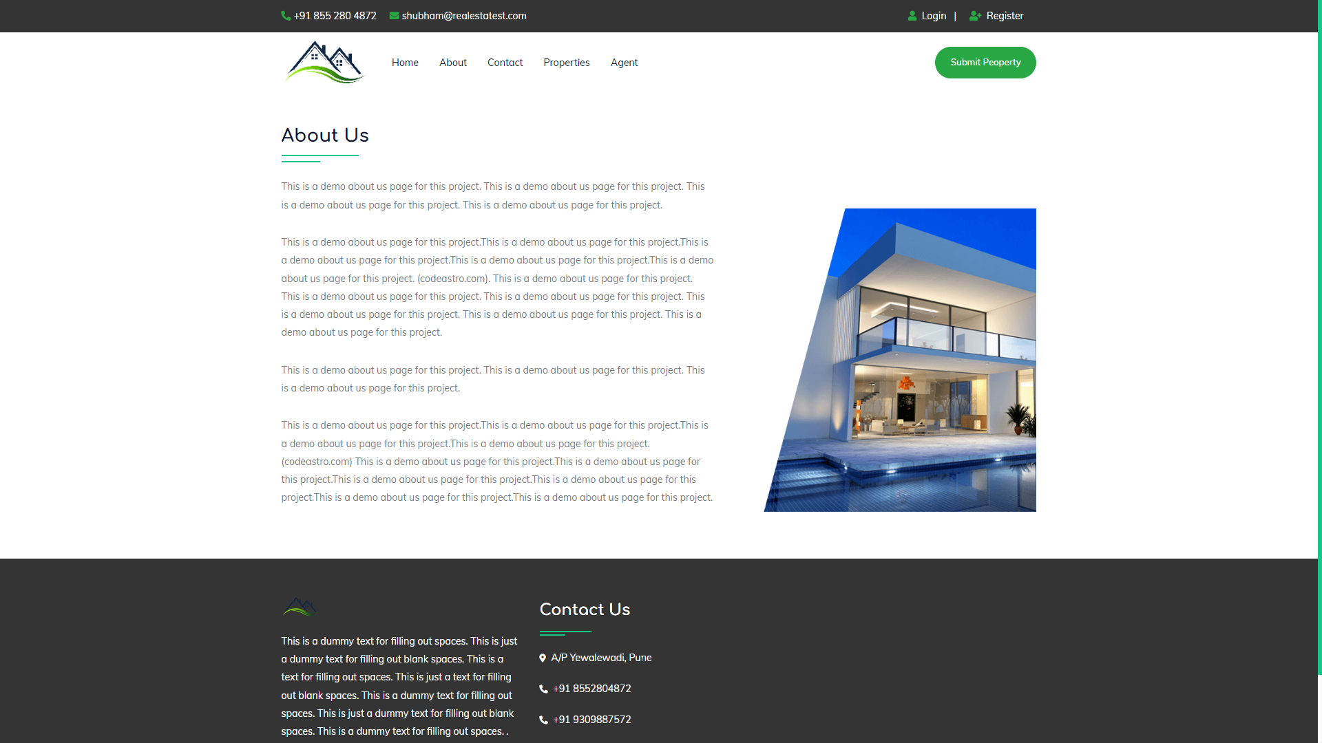



**Contact:**

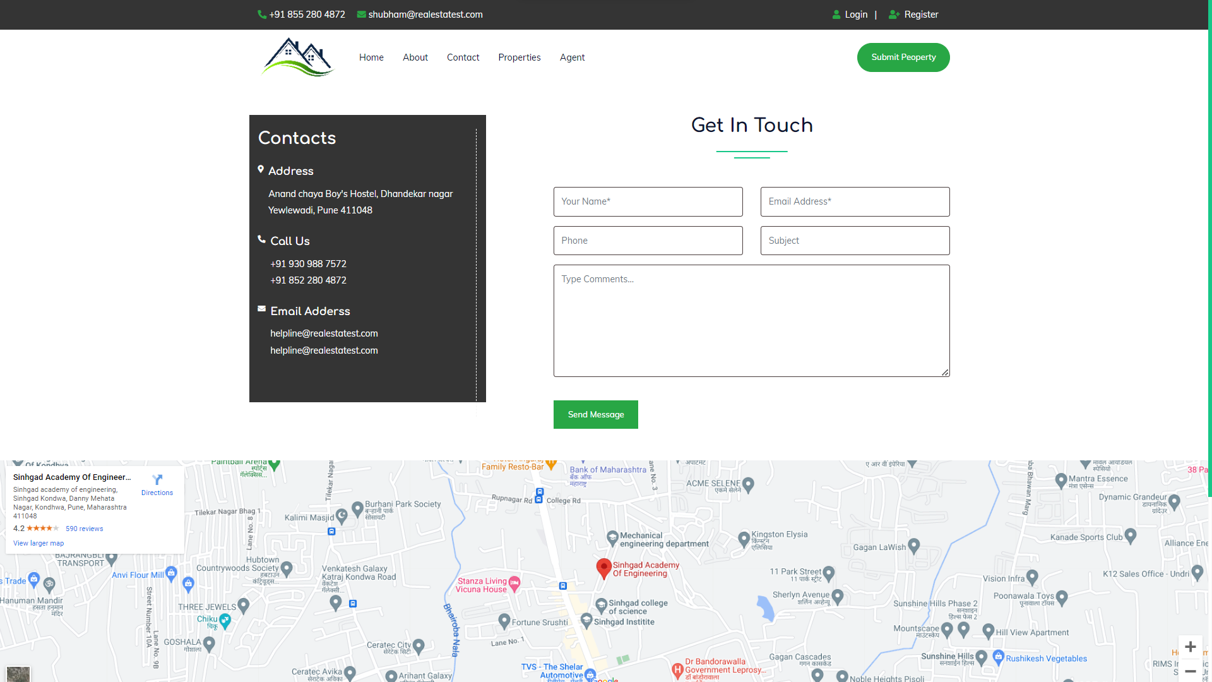

**Property :**

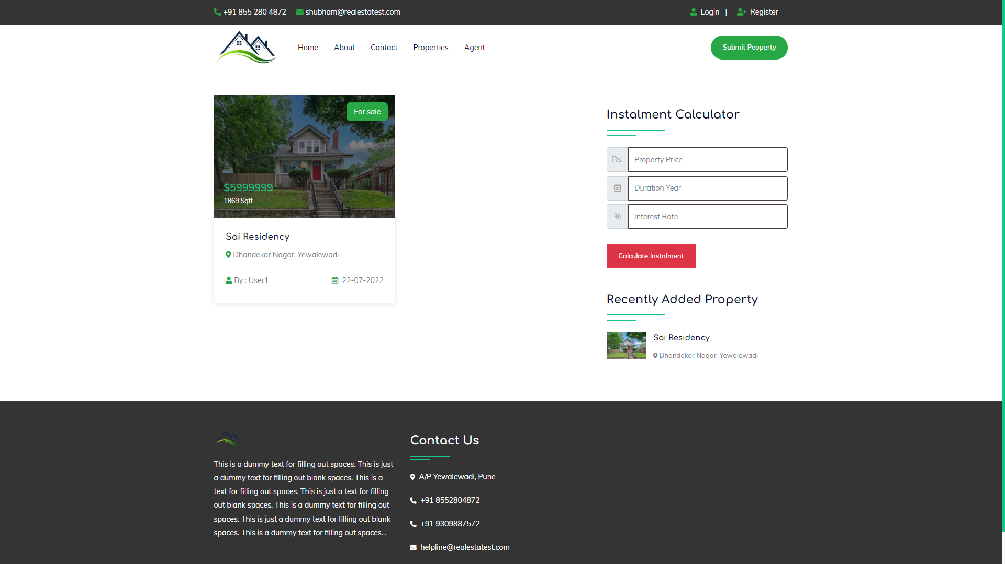

**Agent :**

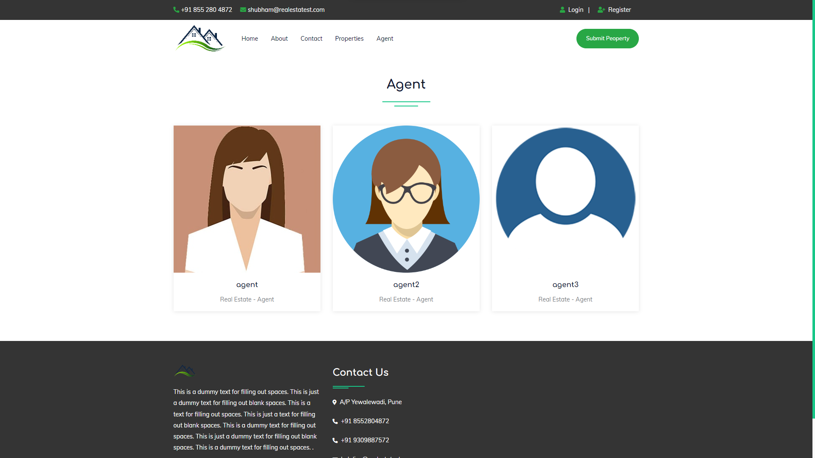

**User Profile:**

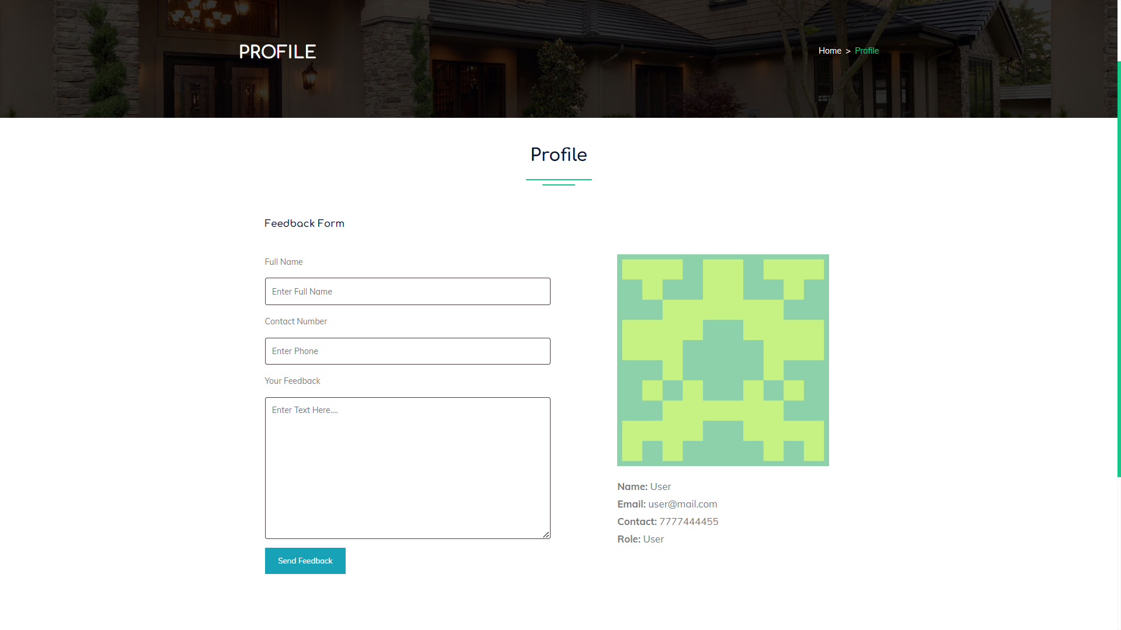

**Your Property:**

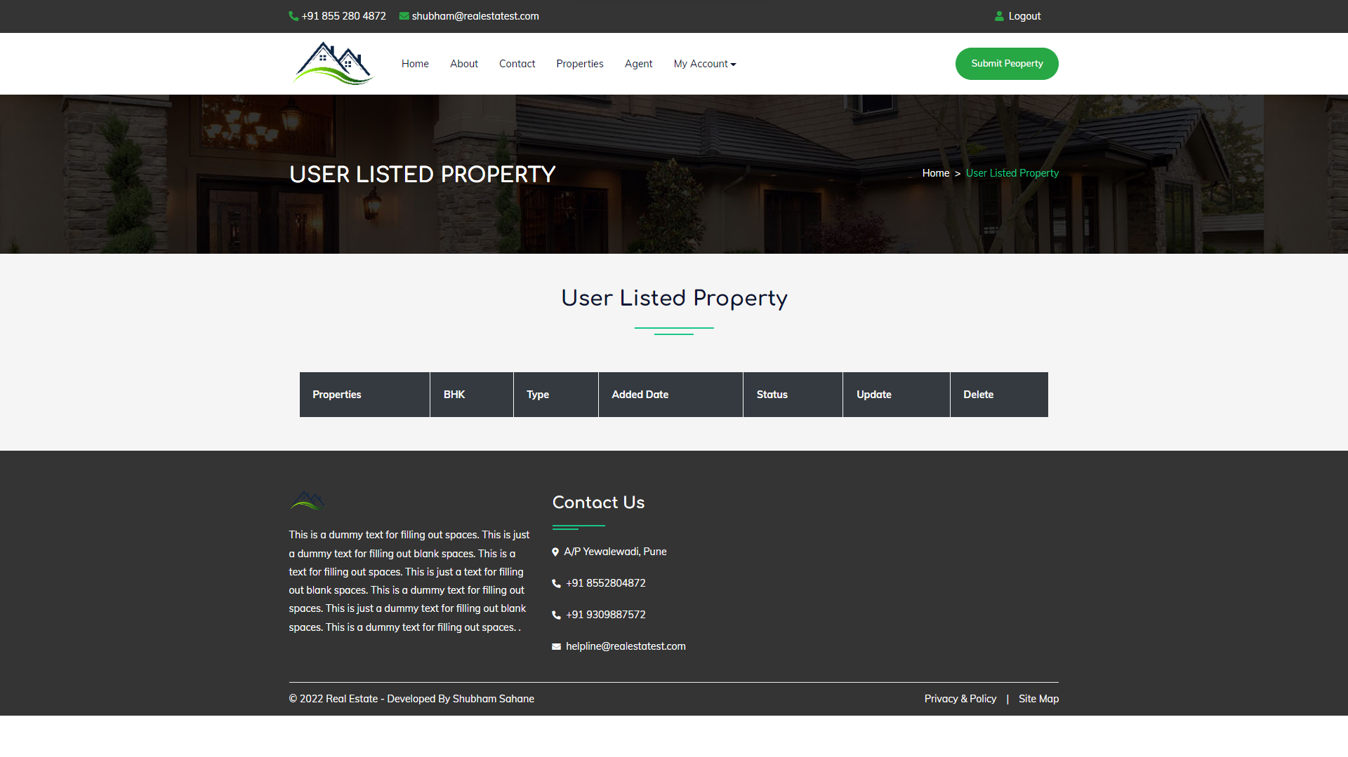

**Property Submit:**

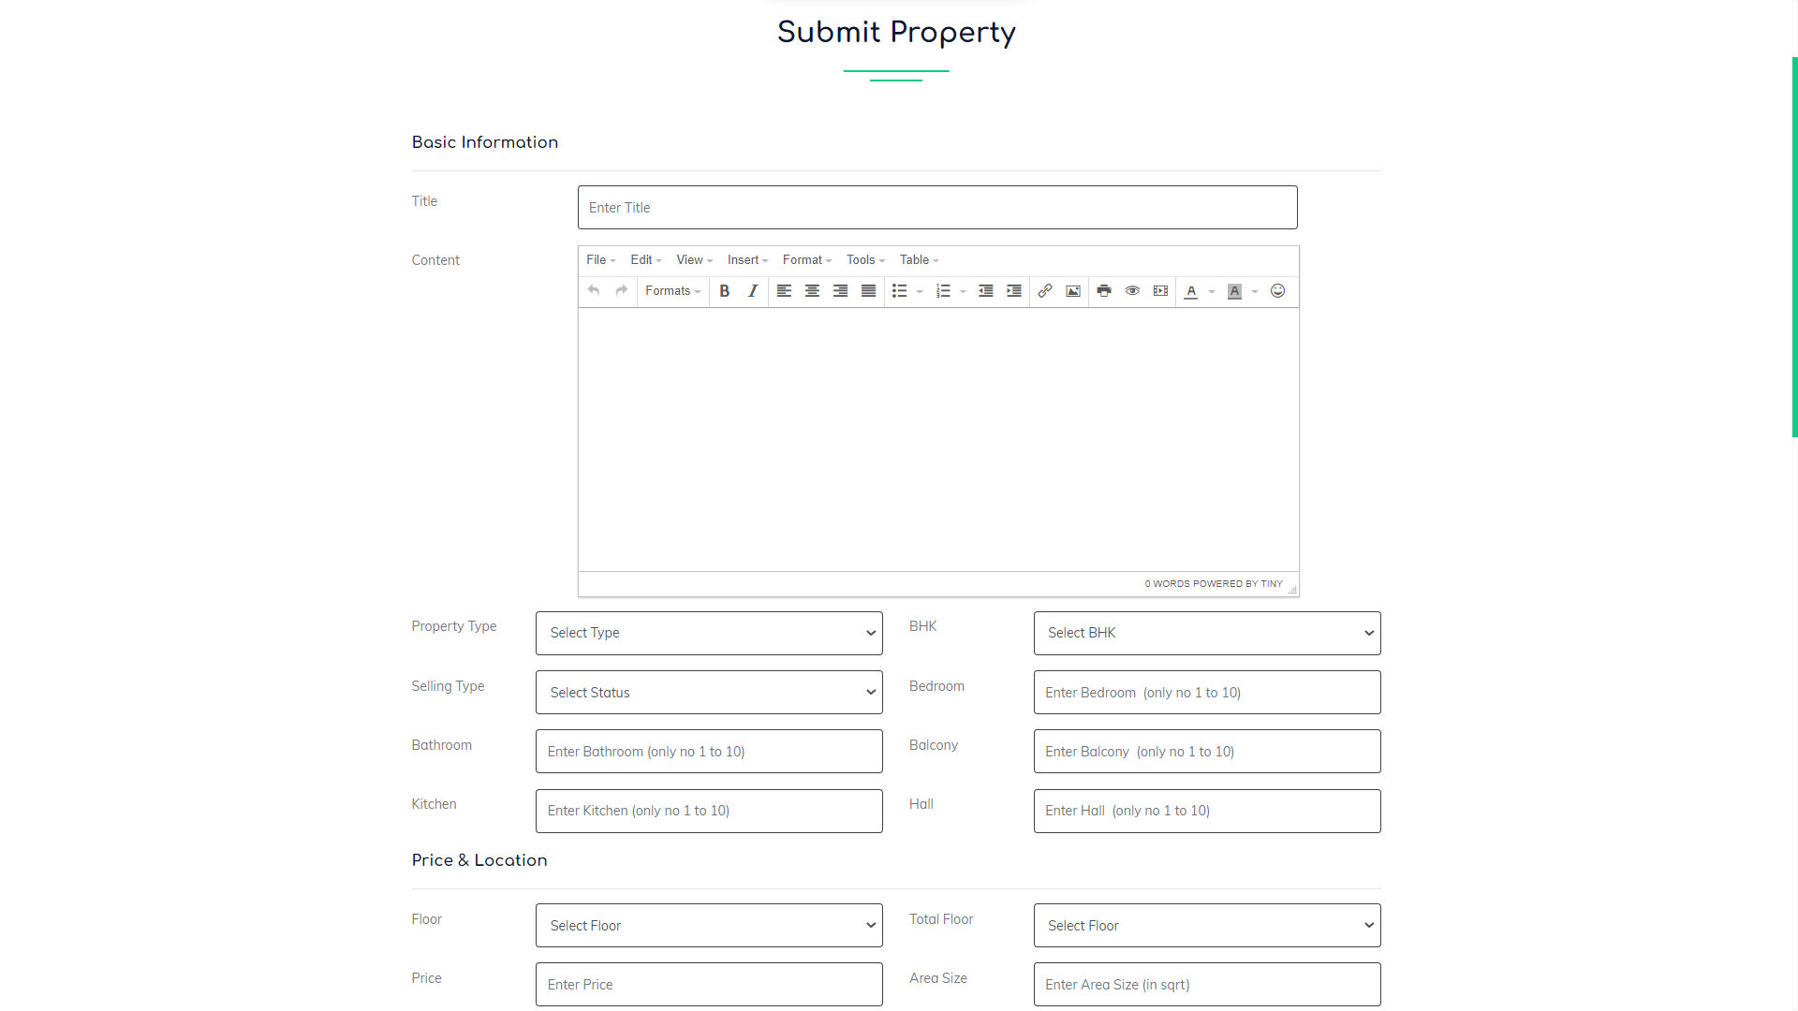

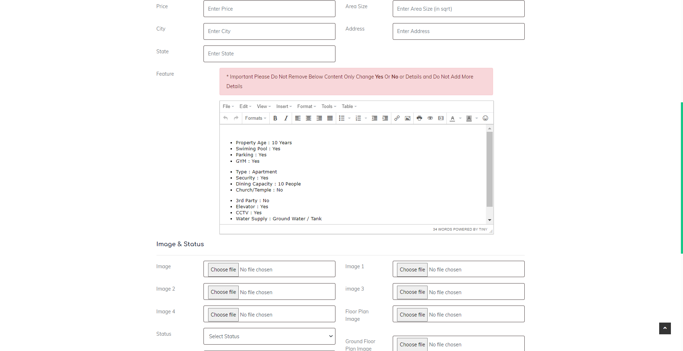



**Admin Dashboard**

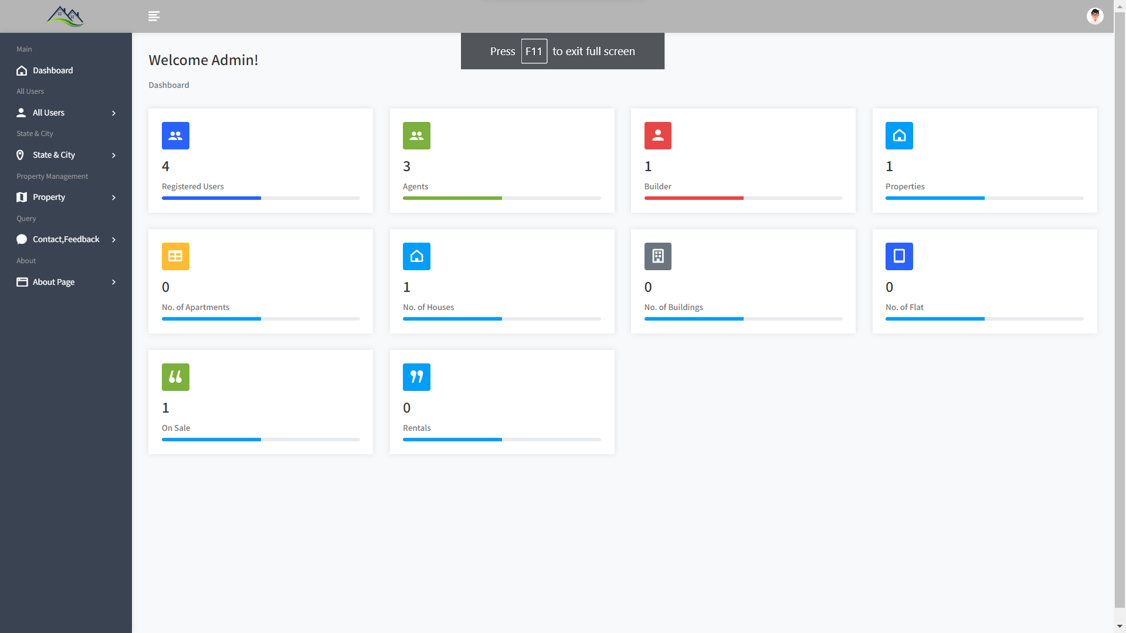

**User Management**

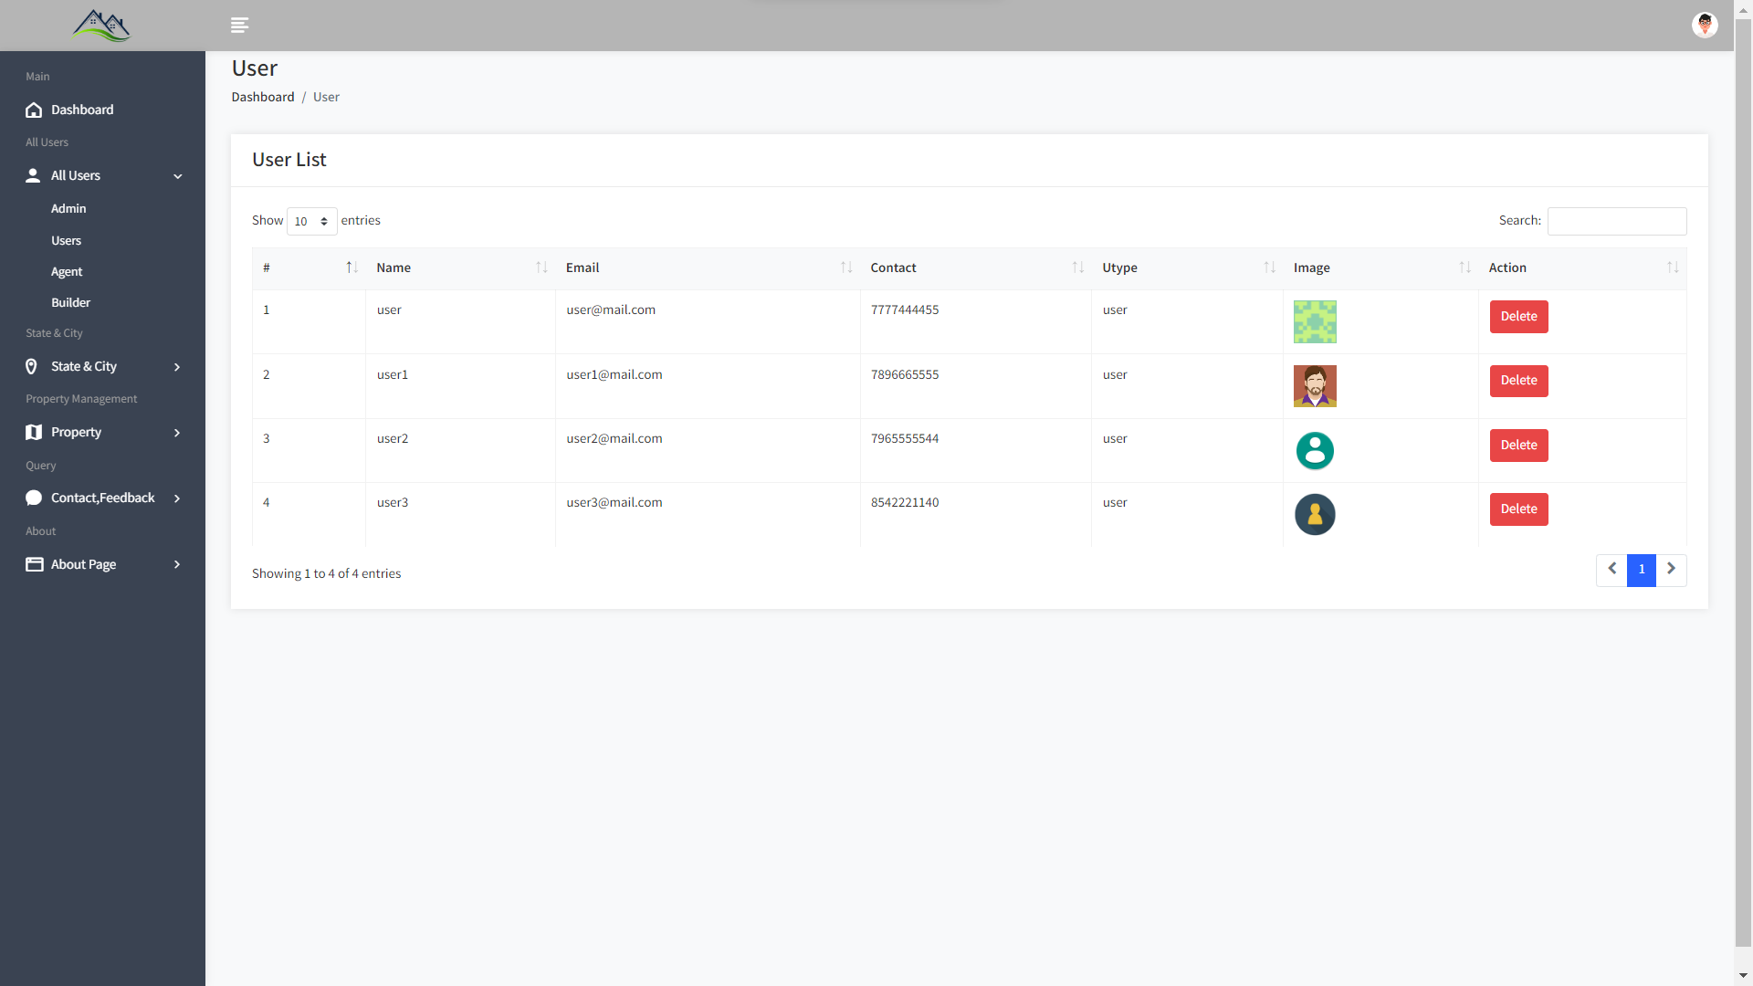

**City / State :**

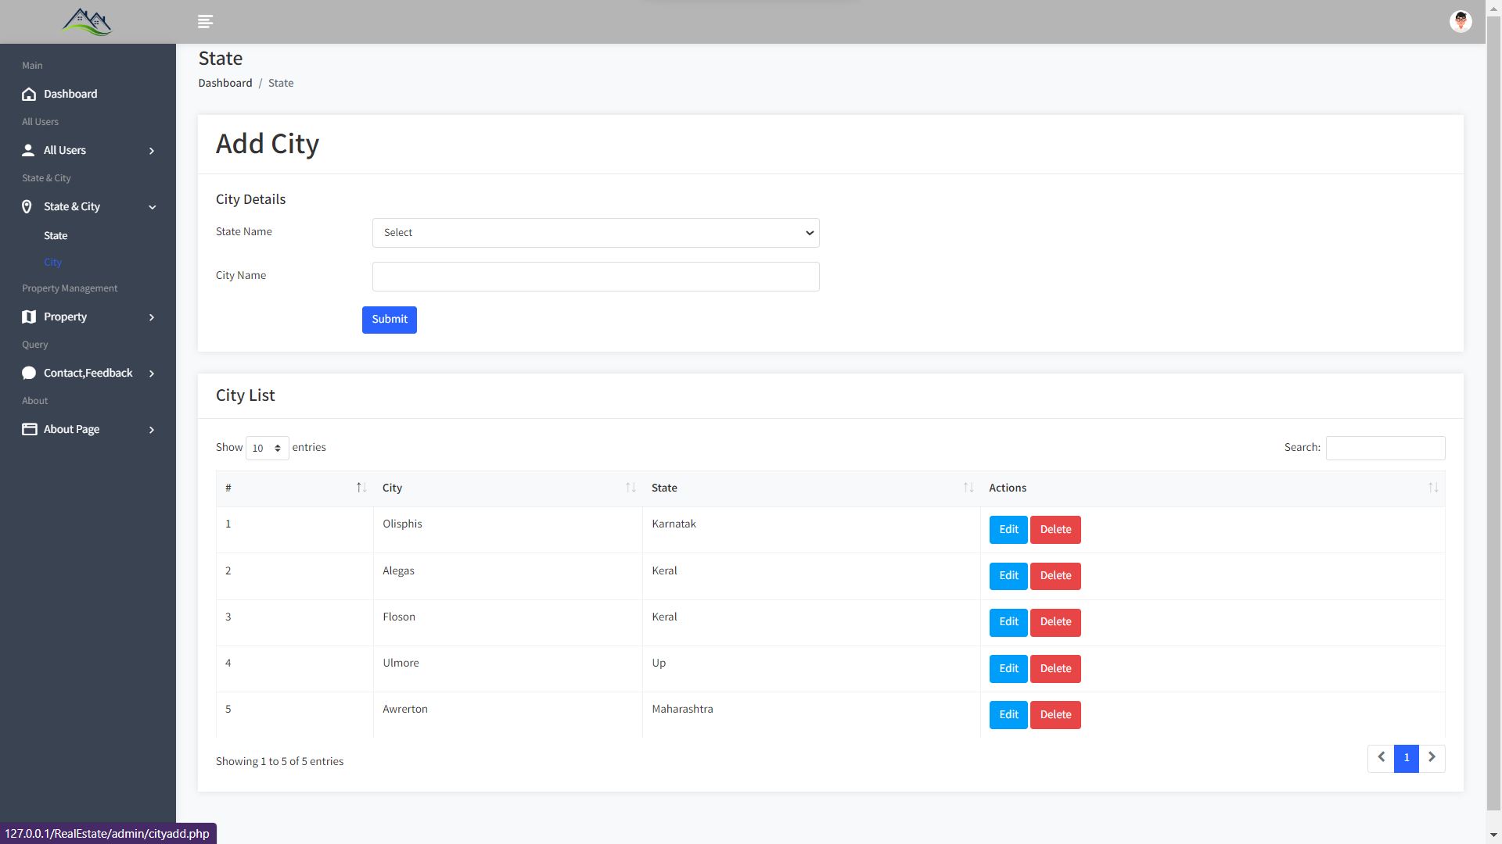

**Add Property:**

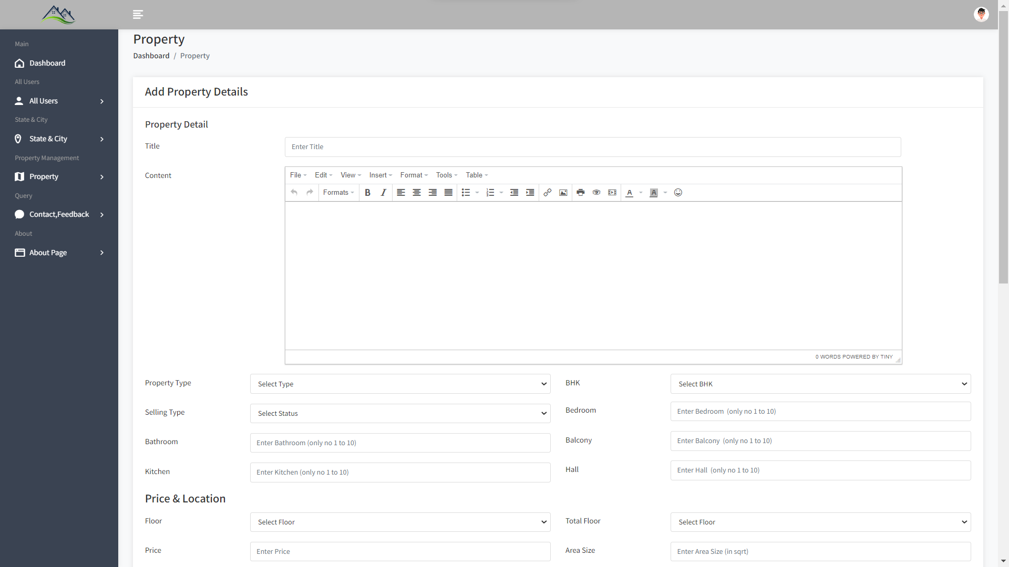

**View All Property**

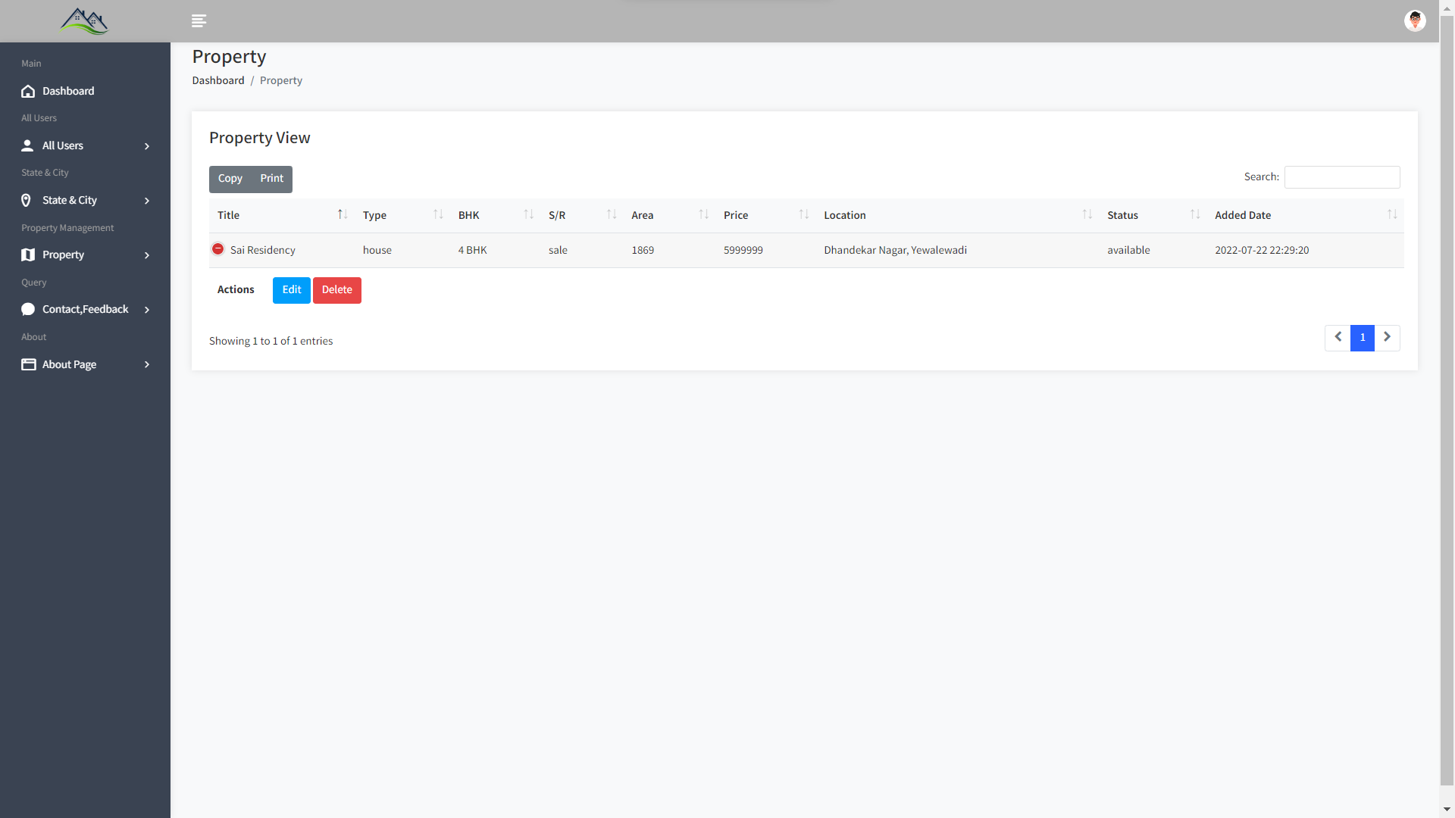

**View Enquery :**

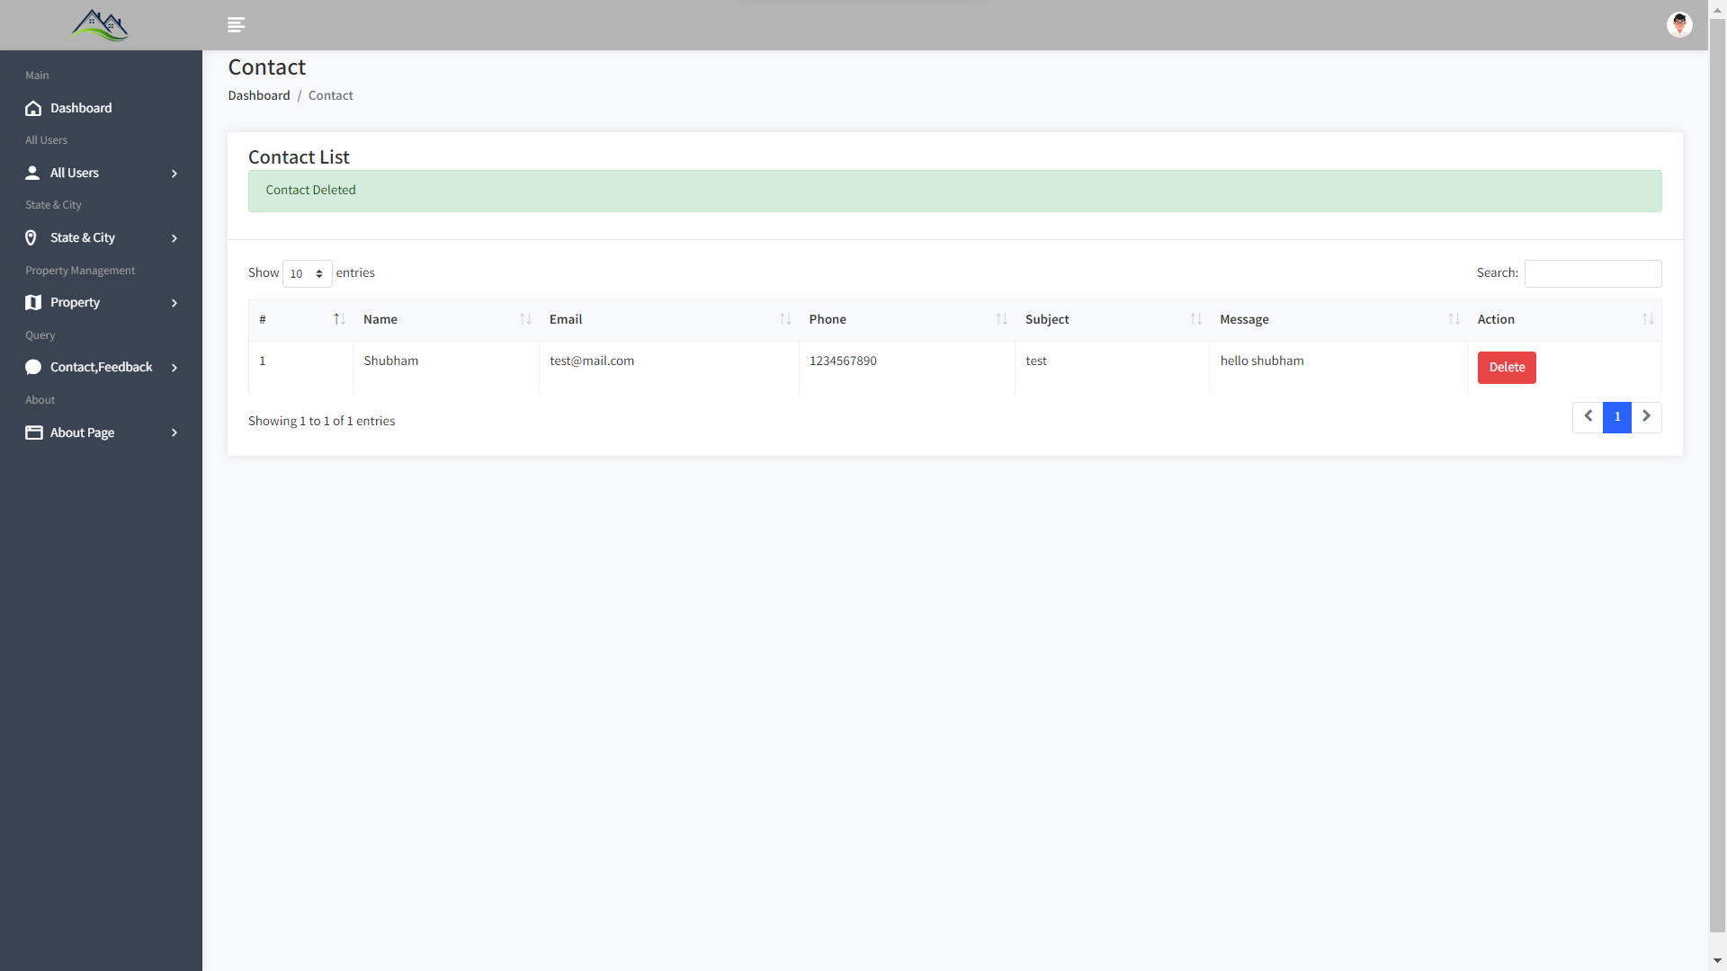

**View Feedback:**

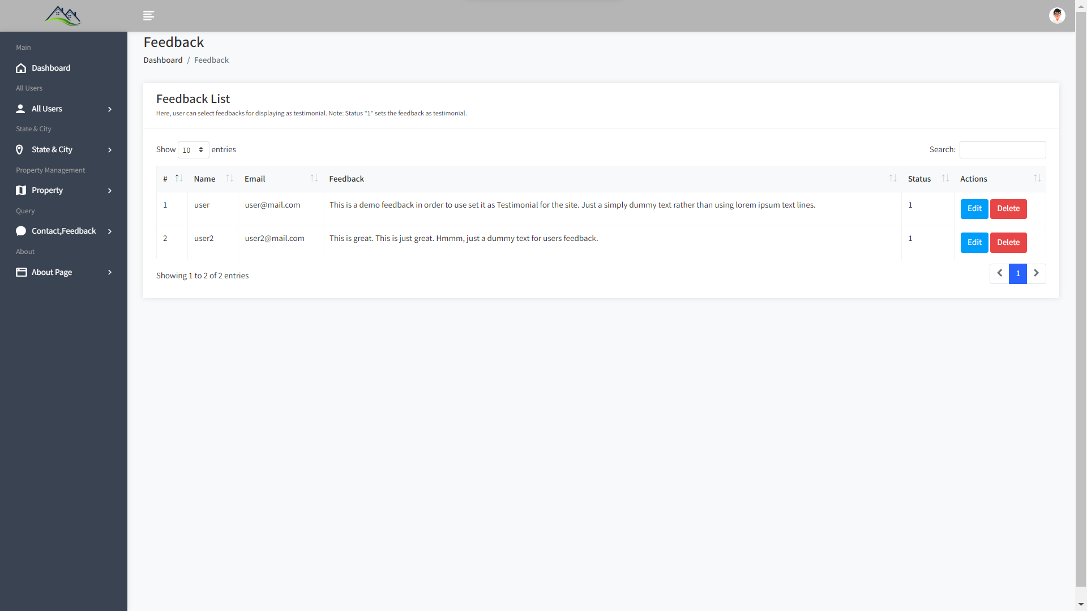

**About Us Update:**

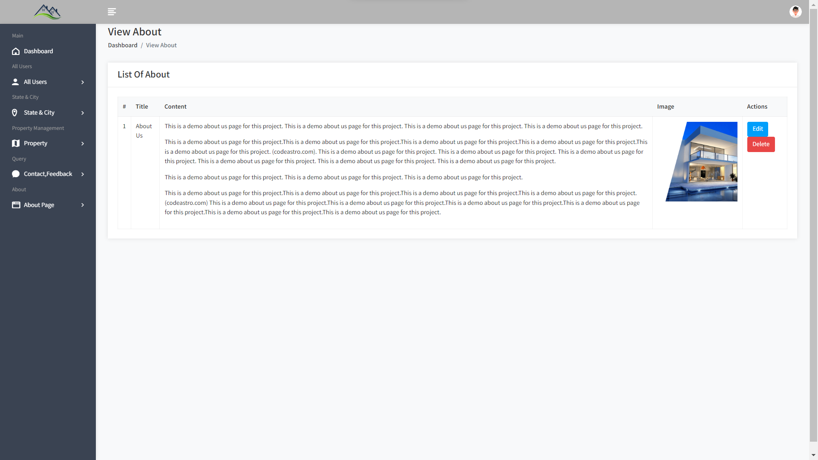

**4.11 Table Specification (Database)**

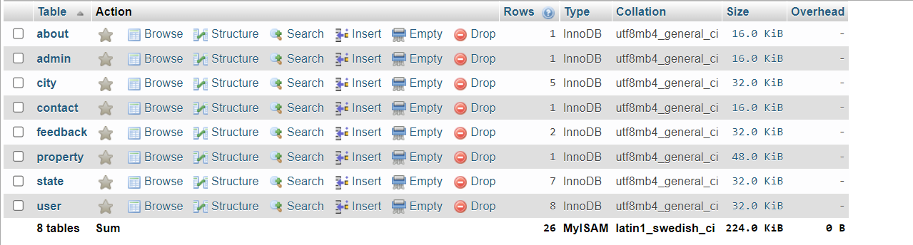

**1 Admin:**

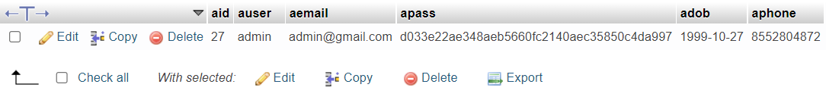

**2 User:**

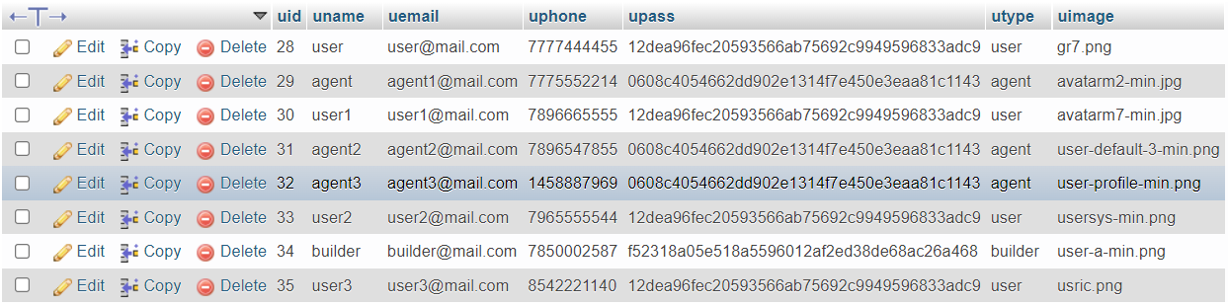

**3 Contact :**

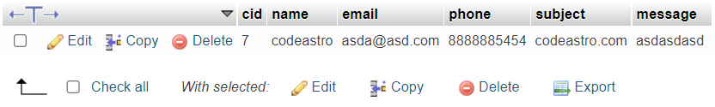

**4 Feedback :**

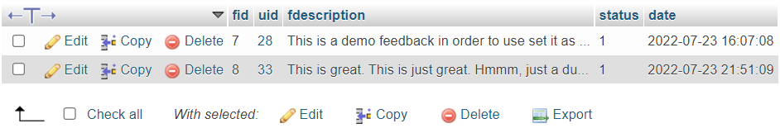

**5 City :**

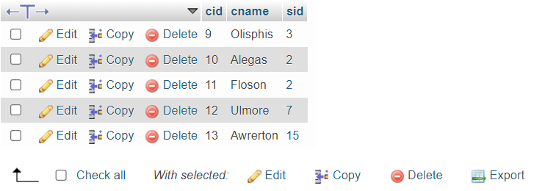

**6 State:**

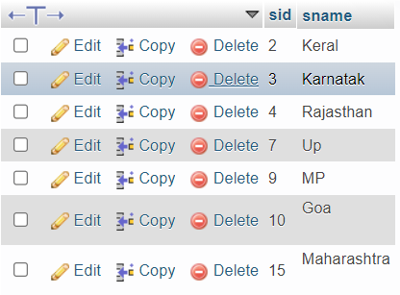

**7 About :**

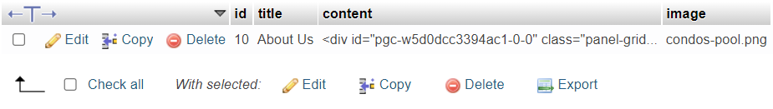

**8 Property:**

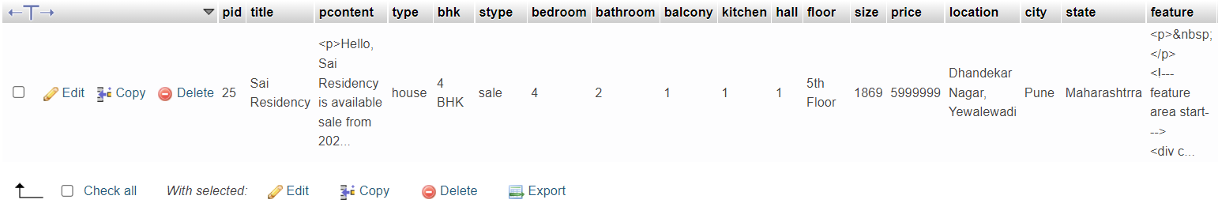

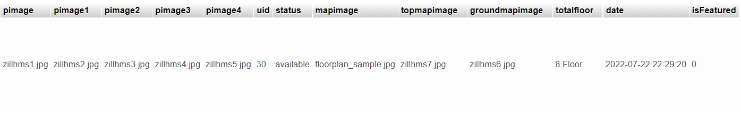

**CHAPTER 5**

**5.1 MENU EXPLANATION:**

**1) Page Details: Property Seller, Instalment Calculator**

* + - When it comes to projects such as real estate systems, the user should also be able to submit their property for sale, and rental purposes. And there is one. The user has to provide a large number of property details. It includes the name of the property, description, pricing details, locations, number of images, features, and much more. With it, the user can also set the property to feature status(codeastro.com). Talking about the featured status, the website simply lists out the top featured properties in the right-hand sidebar. Not just it, every user can list and manage their posted property in order to manage their status. Additionally, the system contains an important feature; an instalment calculator which helps to figure out the total amount that should be paid by the buyers within the instalment period. For that, the user has to enter the total duration with amount and percentage.

**2 ) Page Details :Admin Panel**

* + - An administrator has full control over the system. He/she can manage all the users, states and cities, properties, and so on. Here, each and every section has its own respective details such as name, and other important details. Here, an admin can list out a number of registered users with their levels. The user level consists of admin, agents, builders, and clients. The very first thing of management for the administrator side is to set up state and city information. And with it(codeastro.com), the administrator can also manage properties. In terms of property management, the admin can list out all the available properties. With it, the administrator can make changes to any of the available ones. In fact, the administrator him/herself can post property details following the procedure of it. In addition to it, the admin can have an overview of the system’s record from the dashboard.

**3) Page Details: Contact, Feedback Management and Web Info**

* + - When it comes to projects such as real estate systems, the user should also be able to submit their property for sale, and rental purposes. And there is one. The user has to provide a large number of property details. It includes the name of the property, description, pricing details, locations, number of images, features, and much more. With it, the user can also set the property to feature status(codeastro.com). Talking about the featured status, the website simply lists out the top featured properties in the right-hand sidebar. Not just it, every user can list and manage their posted property in order to manage their status. Additionally, the system contains an important feature; an instalment calculator which helps to figure out the total amount that should be paid by the buyers within the instalment period. For that, the user has to enter the total duration with amount and percentage.

**5.2 DRAWBACK AND LIMITATIONS:**

1. Online Payment Not Available
2. Builder and Agent Module under Constraction

**5.3 PROPOSED ENHANCEMENTS:**

* + - Adding more for agent and builder.
    - Making this system more robust
    - Adding state and city from all over country
    - Adding feacture Rent payment and book property on rent online

**5.4 CONCLUSION:**

Implementation of Real Estate management system project helps to store all kinds of record’s provide coordination and user communication , implement policies , improve day-to-day operations, arrange the supply chain, manage financial and human resources ,and market Real Estate services.

**5.5 BIBLIOGRAPHY:**

**Website :**

* + - https://stackoverflow.com/
    - https://www.javascript.com/learn/
    - https://dev.mysql.com/doc/
    - https://www.quora.com/
    - https://www.javatpoint.com/
    - https://www.w3schools.com/
    - https://www.youtube.com/

**Book’s :**

* + - Artiﬁcial Mind System - Kernel Memory Approach - Tetsuya Hoya
    - Beginning Database Design - Gavin Powell
    - Agile Java Development With Spring, Hibernate, And Eclipse - Anil Hemrajani
    - HTML 5 Black Book: Covers CSS3, Javasvript, XML, XHTML, AJAX, PHP and jQuery - Kogent Learning Solutions Inc.

**ANNEXURE 1**

**ANNEXURE 1 : SAMPLE PROGRAM CODE / PROJECT DEMO**

1. **Database Connection :**

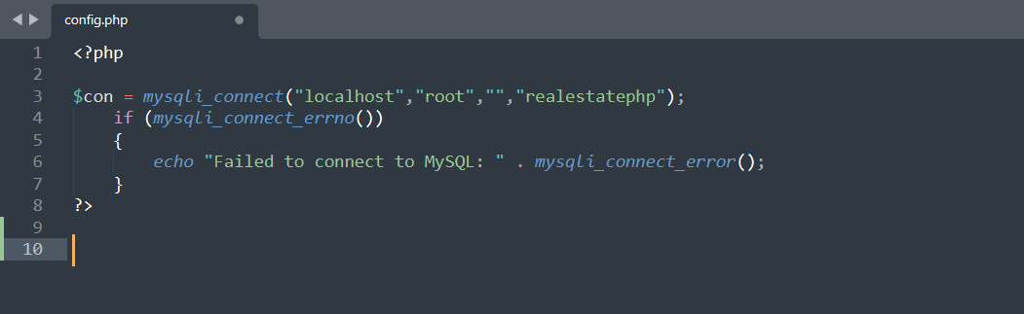

1. **Login :**

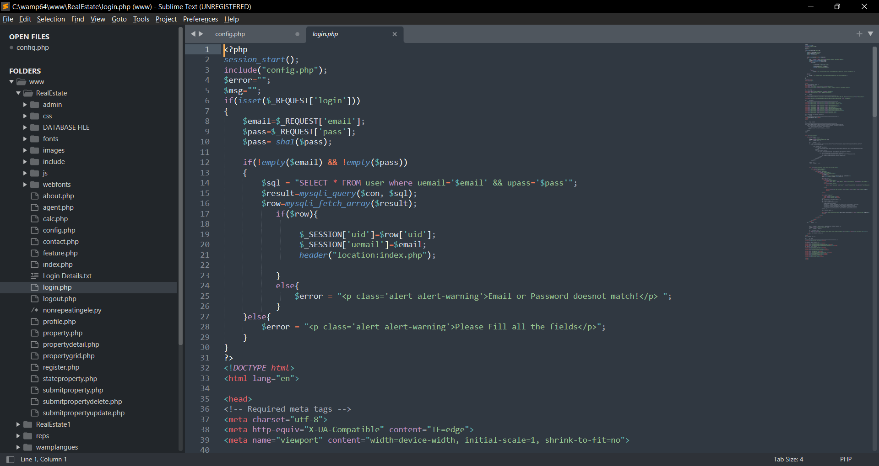

1. **Registration :**

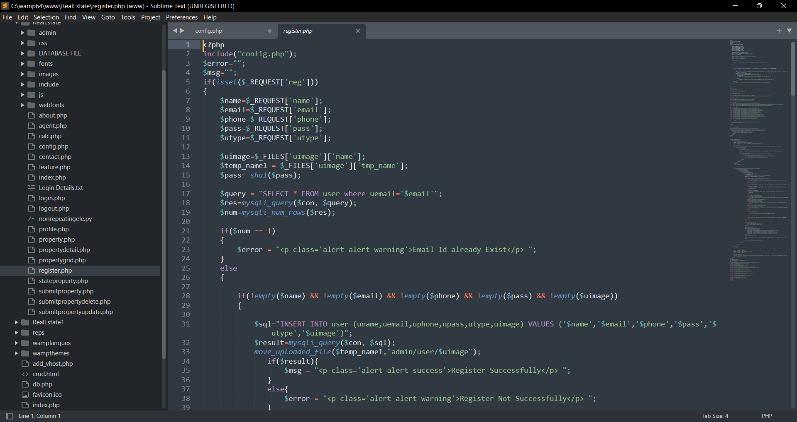

1. **Submit Property:**

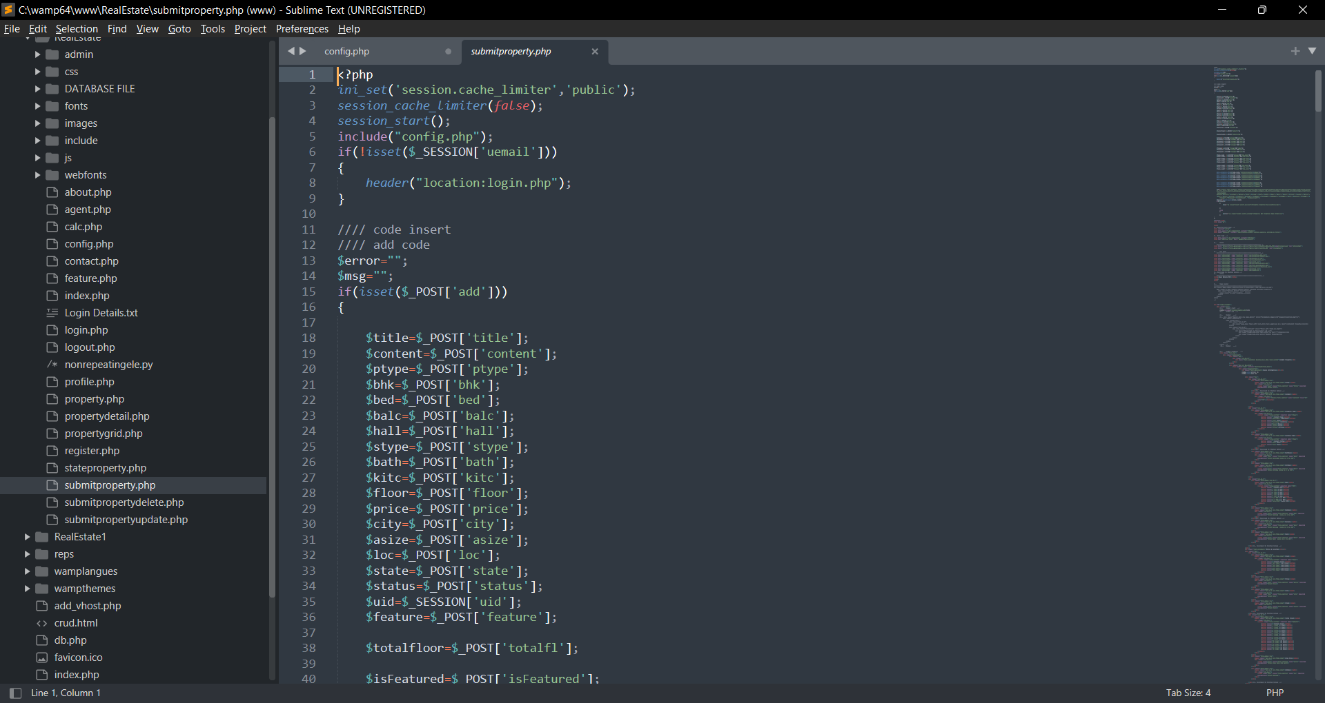

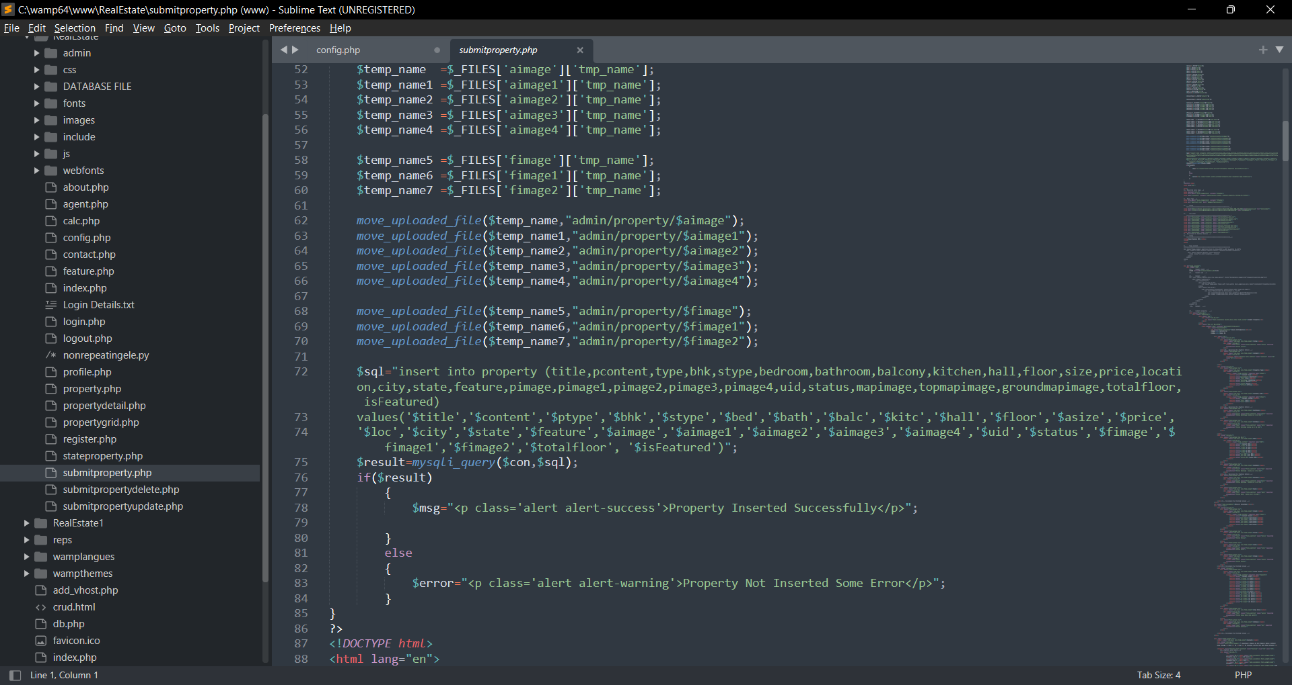

1. **Delete Property:**

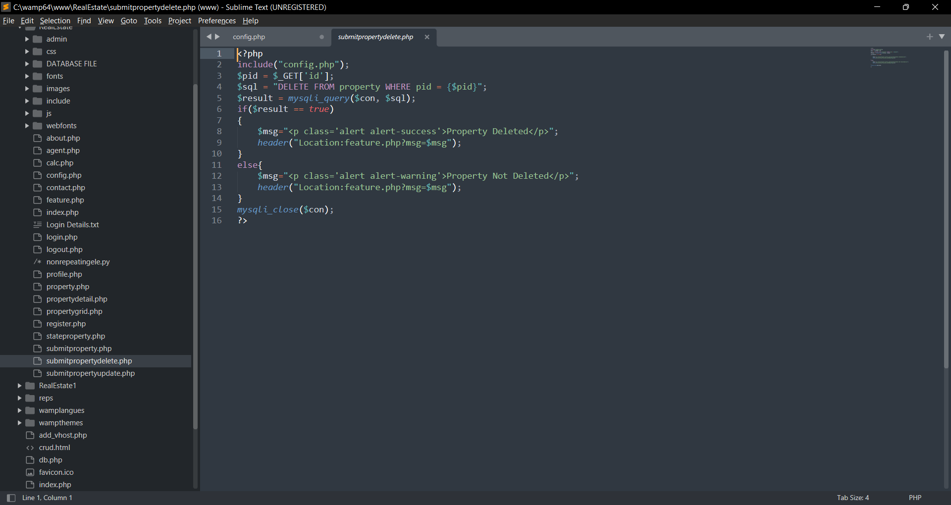

1. **State Add :**

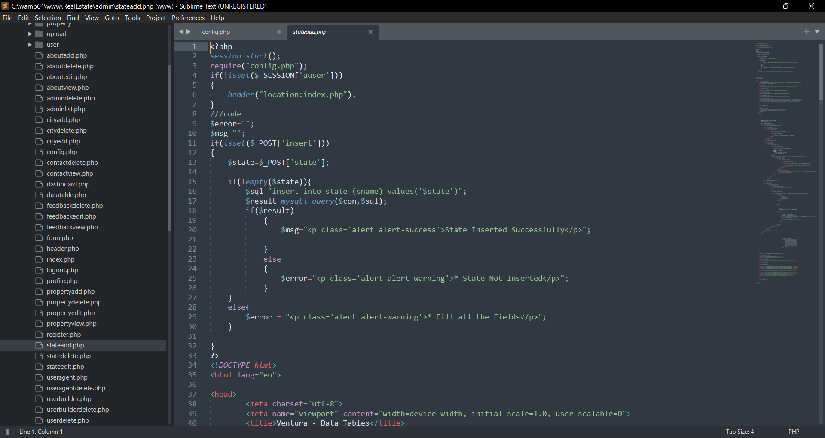

1. **User Agent Delete:**

